** PROJECT REPORT**

**ON**

**“BAKERY MANAGEMENT SYSTEM”**

**Submitted to:**

**Sambalpur University, Odisha**

**for the partial**

**fulfillment of Bachelors in Computer Application**

**(2016-2019)**

**Submitted by: - HARSHA SINGH**

**University Roll No. :- 3117BCA012**

**BCA 3RD Year**

**Under the guidance of**

**DR. Swatee Rekha Mohanty**

**ROURKELA INSTITUTE OF MANAGEMENT STUDIES,ROURKELA**

**(Affiliated to Sambalpur University)**

**ACKNOWLEGEMENT**

**I am Deeply Indebted to Rourkela Institute of Management Studied (RIMS), chhend, Rourkela for providing me an opportunity to undertake the project work entitled “BAKERY MANAGEMNET SYSTEM”.**

**I am highly thankful to my project guide Prof. Swatee Rekha Mohanty for this sincere guidance at every stage in the presentation pf this project.**

**Last but not the least I am also thankful to all the staff of RIMS, for their moral support and encouragement, which makes me to overcome the hurdles that I faced in accomplishing the task successfully.**

** CERTIFICATE**

**This is to certify that it is a bonafied record of the project entitled “BAKERY**

**MANAGEMENT SYSTEM” developed satisfactorily by HARSHA SINGH,**

**Roll no- 3117BC012, under guidance of prof. Swatee Rekha Mohanty.**

**During the period of project work she was found to be sincere and her conduct remained satisfactory.**

**Place:**

**Date:**

**Signature of Signature of the Signature of**

**HOD Internal Guide External Examiner**

**DECLARATION**

I do hereby declare that this project report entitled **BAKERY MANAGEMENT**

**SYSTEM** has been written and submitted under the guidance of **DR.Swatee Rekha Mohanty.** This project is result of my own work and has not been submitted in any other institute or university earlier in what so ever form. The information submitted herein is true and original to the best of my knowledge.

DATE: NAME:

YEAR:

ROLL NO:

**ABSTRACT**

Customer satisfaction is the key to success for any business. In bakery the traditional handwritten method for writing bill keep track of the record is inefficient and leads to loss of the organization. Almost all organization nowadays comprises of the number of task like generate bill, managing records of the stock and customer details. The problem occur is capturing of data and keep accurate records of the stock details daily purchase and sales.

The purpose of our software is to solve all the above problem mention above. As well as fulfill the requirement of our client. The project comprises the list of bakery products displayed in different classification and client can browse through the item.

**CONTENTS**

* INTRODUTION
* OBJECTIVE
* SYSTEM SPECIFICATION
* SYSTEM DESGIN
* DATA DICTIONARY (TABLE STRUCTURE)
* CODING
* OUTPUT SCREEN
* FUTURE SCOPE
* CONCLUSION
* REFERENCE

**INTRODUCTION**

**“BAKERY MANAGEMENT SYSTEM”** when we hear about this word the first thing that strike in our mind is the application which records all the bakery related product and trasncation.

In our application administrator has very vital role the entire task in most of the cases revolves around his/her job. So it is very important to allot admin who has the depth knowledge about the system application and who could use its facilities to the utmost level.

Basically the working of the project is all about the admin and user. The customer can sign up to add a user id provided by a password and attain all the features of the application form and admin on the other hand manages the task. The customer can see the bakery products and can order the products processed with online payment. The customer can leave a message for admin depending on the convenient or inconvenient faced by them

**OBJECTIVES**

Bakery management system, the main motto is to make the workflow flexible and to improve the services provided to the customers. The bakery shop is part of large food service chain that provides desired food items to the customers. The manager of this bakery shop is concerned about delivering on time for customer satisfaction. The first and foremost module is receiving order by the customer. For every new customer a unique id is given. All the details of the customers along with their unique id are maintained in a database so the customer need not specify all his address details each time he places an order. All details of the customer and his order along with his specifications is received and saved. Price varies according to the customers specifications. The implementation of this system has completely changed the existing norm of people moving into bakeries to get their orders because of their busy routines. So, this system is more comfortable in the present busy life and also the timeliness and punctuality keep the customers satisfied.

**SYSTEM SPECIFICATION**

**HARDWARE SPECIFICATION:**

Central Processing Unit : Intel i3

System RAM : 2GB

RAM : 8GB

Keyboard : Laptop

Monitor : Laptop

Mouse : Optical Mouse

Hard Disk : Hitachi 320 GB

**SOFTWARE SPECIFICATION:**

Operating System : Windows

Language : JAVA

Application Developer : Java NetBeans

Database : SQLite

SYSTEM DESGIN

**ENTITY RELATIONSHIP (ER) DIAGRAM**

An entity relationship diagram (ERD) shows the relationships of entity sets stored in a database. An entity in this context is a component of data. In other words, ER diagrams illustrate the logical structure of databases.

At first glance an entity relationship diagram looks very much like a [flowchart](https://www.smartdraw.com/flowchart/). It is the specialized symbols, and the meanings of those symbols, that make it unique.

**Common Entity Relationship Diagram Symbols**

An ER diagram is a means of visualizing how the information a system produces is related. There are five main components of an ERD:

* **Entities**, which are represented by rectangles. An entity is an object or concept about which you want to store information.
* A entity that must defined by a foreign key relationship with another entity as it cannot be uniquely identified by its own attributes alone. 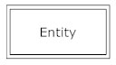
* **Actions**, which are represented by diamond shapes, show how two entities share information in the database. 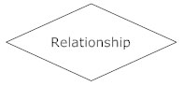In some cases, entities can be self-linked. For example, employees can supervise other employees.  
  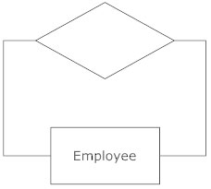
* **Attributes**, which are represented by ovals. A key attribute is the unique, distinguishing characteristic of the entity. For example, an employee's social security number might be the employee's key attribute.   
   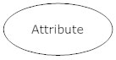
* A multivalued attribute can have more than one value. For example, an employee entity can have multiple skill values.

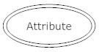

* A derived attribute is based on another attribute. For example, an employee's monthly salary is based on the employee's annual salary.

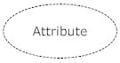

* **Connecting lines**, solid lines that connect attributes to show the relationships of entities in the diagram.
* **Cardinality** specifies how many instances of an entity relate to one instance of another entity. Cardinality is also closely linked to cardinality. While cardinality specifies the occurrences of a relationship, Cardinality describes the relationship as either mandatory or optional. In other words, cardinality specifies the maximum number of relationships and Cardinality specifies the absolute minimum number of relationships.  
  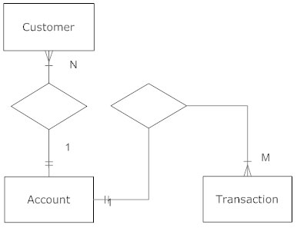
* There are many notation styles that express cardinality.**Information Engineering Style**  
  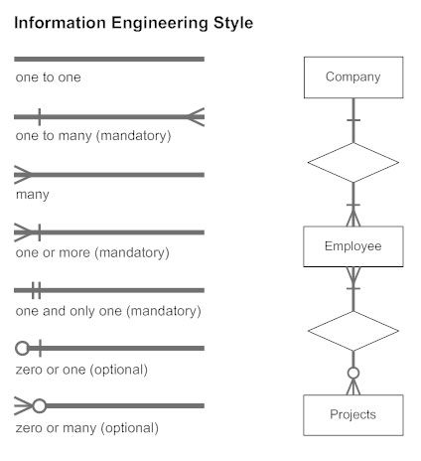
* **Chen Style**  
  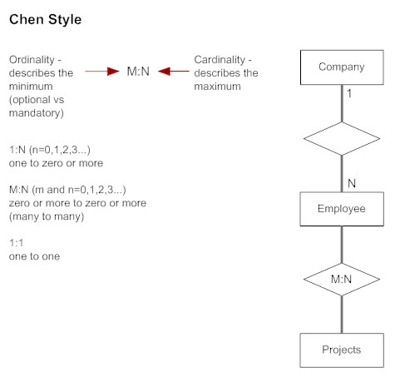

**ER DIAGRAM**

ADMIN

BAKERY

CUSTOMER

PRODUCE

SHIPS ITEM

ORDER

PRODUCTS

ORDER

SHIPPING

PROCESS

PAYMENT

**DATA FLOW DIAGRAM**

**What is Data Flow Diagram?**

A data flow diagram (DFD) is a graphical representation of the “flow of data through an information system. DFDs can also be used for the visualization of data processing (structured design).

A DFDs provide no information about the timing or ordering of processes, or about whether processes will operate in sequence or in parallel. Data flow diagram can flow diagram can be used to provide the end user with a physical idea of where the data the input ultimately an effect upon the structure of the whole system from has order to dispatch to report. However, any system is developed can be determined through a data flow diagram. The circle or bubble represents a transformation process and the label inside the bubble describes the process using an active verb. Data flows are directed lines that identify the input data flow and output data flows at each process bubble. Data storage is represented by open- ended rectangle with a label that identify the data store or file. The square is labeled to identify an external entity that is a source or destination of data flow.

Data flow diagram is used to define the flow to the system and its resources such as information’s. DFD are a way of expressing system requirement in a graphical manner. It has the purpose of the clarifying system. DFD represent one of the most ingenious tools use for structure analysis. It has the purpose of clarifying system requirements and identifying major transformation that will become programs in the system design. The data flow diagram clarifies system requirements that will become programs in system design that decompose the requirements specification down to the lowest level of details

These are two types

* Logical Data Flow of Diagram
* Physical Data Flow of Diagram

Logical Data Flow Diagrams:

The logical data flow diagrams represent the information of data from input to output through processing logically and independently to the physical components of physical components that may be associated with the system.

Physical Data Flow Diagrams:

The Physical Dataflow Diagrams show he actual implementation and movement of data between people, departments and workstations. Each department of Data Flow Diagram is labeled with a descriptive name. process names are further numbered that will ne used for identification purposes. The number of assigned to a specific process does not correspond to the sequence of the processes. It is strictly for identification purpose. A data flow diagram allows parallel activities i.e. a number of data-flows coming out from the source and going into the destination.

Bakery management system Data flow diagram is often used as a preliminary step to create an overview of the Bakery management system without going into great details, which can later be elaborated. It contains all of the user flow and their entities such all the flow of login, login_id, signup, admin, cakes, pastries, bread, cookies.

**Basic data flow diagram symbols-**

Packets of data to travel from one point to another. Data may flow from a source to a process and from data store or process. An arrow line depicts the flow with arrow head pointing in the direction of the flow.

Circles stands for process that converts data into information. A process represents transformation where incoming data flows. A data flow is a rout which enables are change into outgoing data flows.

A data store is a repository of data that is to be stored for use by a one or more process may be as simple as buffer or queue or sophisticated as relational data base. They should have

clear names. If a process merely uses the content of store and does not alter it, the arrowhead goes only from the store to the process. If a process alters the details in the store then a double headed arrow is used.

A source or sink is a person or part of an organization which enter or receives information from the system but is considered to be outside the contest of data flow model.

**ZERO LEVEL DATA FLOW DIAGRAM**

This is the zero level DFD of bakery management system, where we have elaborated the high level process of bakery management. Its basic overview of the whole bakery management system or process being analyzed or modeled.

PRODUCT MANAGEMENT

LOGIN MANAGEMENT

SYSTEM MANAGEMENT

**FIRST LEVEL DATA FLOW DAIGRAM**

USER

Authentication Customer ID & Password

ACCOUNT DB INFO

Admin Password

ADMIN

ORDER

CUSTOMER

ORDER DETAILS

DB INFO

ADMIN

ORDER

DETAILS

INFO

ADMIN

CUSTOMER DB

VIEW

SEND

CUSTOMER

CONTACT US DB IN

ADMIN

DATA DICTIONARY

(TABLE STRUCTURE)

**SIGNUP AND LOGIN TABLE (Info table)**

|  |  |  |  |  |
| --- | --- | --- | --- | --- |
| Field Name | Data Type | Field Size | Constraints | Description |
| UserId | Varchar | 6 | Primary key  Unique  Not null | Unique ID for all customers |
| Name | Text | 25 | Not null | Full name of customer |
| Email | Varchar | 20 | Not null | Email ID of customer |
| Pwd | Varchar | 10 | Not null | Login password for customer |
| Gender | Text | 6 | Not null | Gender of customer |
| Mobile | Integer | 10 | Not null | Mobile number of customer |
| State | Text | 10 | Not null | State name of customer |
| Full_address | Varchar | 30 | Not null | Full address of customer |

Create table Info

(

UserId varchar (6) PRIMARY KEY UNIQUE NOT NULL,

Name text (25) NOT NULL,

Email varchar (10) NOT NULL,

Pwd varchar (10) NOT NULL,

Gender text (6) NOT NULL,

Mobile integer (10) NOT NULL,

State text (10) NOT NULL,

Full address varchar (30) NOT NULL

);

**ADMIN LOGIN TABLE (Admin table)**

|  |  |  |  |  |
| --- | --- | --- | --- | --- |
| Field Name | Data Type | Field Size | Constraints | Description |
| AdminID | Varchar | 6 | Primary key  Unique  Not null | Unique ID for system admin |
| Password | Varchar | 10 | Not null | Login password for system admin |

Create table Admin

(

AdminID varchar (6) PRIMARY KEY UNIQUE NOT NULL,

Password varchar (10) NOT NULL

);

**CONTACT US TABLE (Contactus table)**

|  |  |  |  |  |
| --- | --- | --- | --- | --- |
| Field Name | Data Type | Field Size | Constraints | Description |
| Name | Text | 20 | Not null | Full name of customer |
| Email | Varchar | 15 | Not null | Email ID of customer |
| Mobile | Integer | 10 | Not null | Mobile number of customer |
| Subject | Varchar | 15 | Not null | Subject of a message |
| Message | Varchar | 30 | Not null | Message for system admin |

Create Table Contactus

(

Name text (20) NOT NULL,

Email varchar (15) NOT NULL,

Mobile integer (10) NOT NULL,

Subject varchar (15) NOT NULL,

Message Varchar (30) NOT NULL

);

**ORDER DETAILS TABLE (Orderinfo table)**

|  |  |  |  |  |
| --- | --- | --- | --- | --- |
| Field Name | Data Type | Field Size | Constraints | Description |
| ProductID | Varchar | 7 | Not null | ID of a product |
| Name | Text | 20 | Not null | Name of product |
| Type | Text | 7 | Not null | Product is egg or eggless |
| Quantity | Integer | 2 | Not null | Number of product ordered |
| TotalAmount | Double | 8 | Not null | Total price of order |

Create table Orderinfo

(

ProductID varchar (7) NOT NULL,

Name Text (20) NOT NULL,

Type text (7) NOT NULL,

Quantity integer (2) NOT NULL,

TotalAmount double (8) NOT NULL

);

**SHIPPING ADDRESS TABLE (Shipping table)**

|  |  |  |  |  |
| --- | --- | --- | --- | --- |
| Field Name | Data Type | Field Size | Constraints | Description |
| Userid | Varchar | 6 | Not null | ID of customer |
| Name | Text | 20 | Not null | Name of customer |
| Houseno | Varchar | 5 | Not null | House number of customer’s home |
| Street | Text | 10 | Not null | Street name for shipping |
| City | Text | 10 | Not null | City name for shipping |
| Pincode | Integer | 6 | Not null | Pincode number of area for shipping |
| State | Text | 10 | Not null | State name for shipping |
| Country | Text | 10 | Not null | Country name for shipping |

Create table Shipping

(

Userid varchar (6) NOT NULL,

Name text (20) NOT NULL,

Houseno Varchar (5) NOT NULL,

Street text (10) NOT NULL,

City text (10) NOT NULL,

Pincode Integer (6) NOT NULL,

State text (10) NOT NULL,

Country text (10) NOT NULL

);

CODING

**WELCOME FORM**

import java.awt.*;

import java.awt.event.*;

public class Welcome extends javax.swing.JFrame {

public Welcome() {

initComponents();

}

private void initComponents()

jButton1 = new javax.swing.JButton();

jLabel1 = new javax.swing.JLabel();

jLabel2 = new javax.swing.JLabel();

jLabel3 = new javax.swing.JLabel();

jLabel4 = new javax.swing.JLabel();

setDefaultCloseOperation(javax.swing.WindowConstants.DISPOSE_ON_CLOSE);

setName("front page");

setPreferredSize(new java.awt.Dimension(901, 531));

setResizable(false);

setSize(new java.awt.Dimension(900, 530));

getContentPane().setLayout(null);

jButton1.setFont(new java.awt.Font("Colonna MT", 1, 36));

jButton1.setText("VISIT");

jButton1.addActionListener(new java.awt.event.ActionListener() {

public void actionPerformed(java.awt.event.ActionEvent evt) {

jButton1ActionPerformed(evt);

}

});

getContentPane().add(jButton1);

jButton1.setBounds(370, 450, 130, 40);

jLabel1.setFont(new java.awt.Font("Cooper Black", 3, 48));

jLabel1.setForeground(new java.awt.Color(255, 0, 0));

jLabel1.setText("BAKERY");

getContentPane().add(jLabel1);

jLabel1.setBounds(300, 120, 300, 60);

jLabel2.setFont(new java.awt.Font("Cooper Black", 3, 48));

jLabel2.setForeground(new java.awt.Color(255, 0, 0));

jLabel2.setText("MANAGEMENT");

getContentPane().add(jLabel2);

jLabel2.setBounds(230, 230, 420, 70);

jLabel3.setFont(new java.awt.Font("Cooper Black", 3, 48));

jLabel3.setForeground(new java.awt.Color(255, 0, 0));

jLabel3.setText("SYSTEM");

getContentPane().add(jLabel3);

jLabel3.setBounds(320, 350, 250, 56);

jLabel4.setIcon(new javax.swing.ImageIcon("E:\\java project\\Bakery management system\\image\\welcome.jpg"));

jLabel4.setText("jLabel4");

getContentPane().add(jLabel4);

jLabel4.setBounds(0, 0, 900, 530);

pack();

}

private void jButton1ActionPerformed(java.awt.event.ActionEvent evt) {

Optionlogin ob=new Optionlogin();

ob.setVisible(true);

dispose();

}

public static void main(String args[]) {

try {

for (javax.swing.UIManager.LookAndFeelInfo

info : javax.swing.UIManager.getInstalledLookAndFeels())

{

if ("Nimbus".equals(info.getName())) {

javax.swing.UIManager.setLookAndFeel(info.getClassName());

break;

}

}

}

catch (ClassNotFoundException ex) {

java.util.logging.Logger.getLogger(Welcome.class.getName()).log(java.util.logging.Level.SEVERE, null, ex);

}

catch (InstantiationException ex) {

java.util.logging.Logger.getLogger(Welcome.class.getName()).log(java.util.logging.Level.SEVERE, null, ex);

}

catch (IllegalAccessException ex) {

java.util.logging.Logger.getLogger(Welcome.class.getName()).log(java.util.logging.Level.SEVERE, null, ex);

}

catch (javax.swing.UnsupportedLookAndFeelException ex) {

java.util.logging.Logger.getLogger(Welcome.class.getName()).log(java.util.logging.Level.SEVERE, null, ex);

}

java.awt.EventQueue.invokeLater(new Runnable() {

public void run() {

new Welcome().setVisible(true);

}

});

}

private javax.swing.JButton jButton1;

private javax.swing.JLabel jLabel1;

private javax.swing.JLabel jLabel2;

private javax.swing.JLabel jLabel3;

private javax.swing.JLabel jLabel4;

}

**OPTION LOGIN FORM**

import java.awt.Toolkit;

import java.awt.event.WindowEvent;

public class Optionlogin extends javax.swing.JFrame {

public Optionlogin() {

initComponents();

}

private void initComponents() {

jButton1 = new javax.swing.JButton();

jButton2 = new javax.swing.JButton();

jButton3 = new javax.swing.JButton();

jLabel1 = new javax.swing.JLabel();

setDefaultCloseOperation(javax.swing.WindowConstants.DISPOSE_ON_CLOSE);

setMaximumSize(new java.awt.Dimension(900, 530));

setPreferredSize(new java.awt.Dimension(902, 532));

setResizable(false);

setSize(new java.awt.Dimension(900, 530));

getContentPane().setLayout(null);

jButton1.setFont(new java.awt.Font("Perpetua", 1, 24));

jButton1.setText("CUSTOMER LOGIN");

jButton1.addActionListener(new java.awt.event.ActionListener() {

public void actionPerformed(java.awt.event.ActionEvent evt) {

jButton1ActionPerformed(evt);

}

});

getContentPane().add(jButton1);

jButton1.setBounds(120, 160, 250, 40);

jButton2.setFont(new java.awt.Font("Perpetua", 1, 24));

jButton2.setText("CUSTOMER SIGNUP");

jButton2.addActionListener(new java.awt.event.ActionListener() {

public void actionPerformed(java.awt.event.ActionEvent evt) {

jButton2ActionPerformed(evt);

}

});

getContentPane().add(jButton2);

jButton2.setBounds(120, 250, 250, 37);

jButton3.setFont(new java.awt.Font("Perpetua", 1, 24));

jButton3.setText("ADMIN LOGIN");

jButton3.addActionListener(new java.awt.event.ActionListener() {

public void actionPerformed(java.awt.event.ActionEvent evt) {

jButton3ActionPerformed(evt);

}

});

getContentPane().add(jButton3);

jButton3.setBounds(120, 340, 250, 37);

jLabel1.setIcon(new javax.swing.ImageIcon("E:\\java project\\Bakery management system\\image\\option.jpg"));

jLabel1.setText("jLabel1");

jLabel1.setMaximumSize(new java.awt.Dimension(943, 530));

jLabel1.setMinimumSize(new java.awt.Dimension(943, 530));

jLabel1.setPreferredSize(new java.awt.Dimension(900, 530));

getContentPane().add(jLabel1);

jLabel1.setBounds(0, 0, 900, 530);

pack();

}

private void jButton1ActionPerformed(java.awt.event.ActionEvent evt) {

Login l = new Login();

l.setVisible(true);

dispose();

}

private void jButton2ActionPerformed(java.awt.event.ActionEvent evt) {

Signup s = new Signup();

s.setVisible(true);

dispose();

}

private void jButton3ActionPerformed(java.awt.event.ActionEvent evt) {

Adminlogin a = new Adminlogin();

a.setVisible(true);

dispose();

}

public static void main(String args[]) {

try {

for (javax.swing.UIManager.LookAndFeelInfo info : javax.swing.UIManager.getInstalledLookAndFeels()) {

if ("Nimbus".equals(info.getName())) {

javax.swing.UIManager.setLookAndFeel(info.getClassName());

break;

}

}

}

catch (ClassNotFoundException ex) {

java.util.logging.Logger.getLogger(Optionlogin.class.getName()).log(java.util.logging.Level.SEVERE, null, ex);

}

catch (InstantiationException ex) {

java.util.logging.Logger.getLogger(Optionlogin.class.getName()).log(java.util.logging.Level.SEVERE, null, ex);

}

catch (IllegalAccessException ex) {

java.util.logging.Logger.getLogger(Optionlogin.class.getName()).log(java.util.logging.Level.SEVERE, null, ex);

}

catch (javax.swing.UnsupportedLookAndFeelException ex) {

java.util.logging.Logger.getLogger(Optionlogin.class.getName()).log(java.util.logging.Level.SEVERE, null, ex);

}

java.awt.EventQueue.invokeLater(new Runnable() {

public void run() {

new Optionlogin().setVisible(true);

}

});

}

private javax.swing.JButton jButton1;

private javax.swing.JButton jButton2;

private javax.swing.JButton jButton3;

private javax.swing.JLabel jLabel1;

}

**SIGNUP FORM**

import java.sql.*;

import javax.swing.JOptionPane;

public class Signup extends javax.swing.JFrame {

Connection con;

ResultSet rs;

PreparedStatement pst;

public Signup() {

initComponents();

con = dbconnect.ConnecrDB();

}

private void initComponents() {

buttonGroup1 = new javax.swing.ButtonGroup();

jLabel1 = new javax.swing.JLabel();

jLabel2 = new javax.swing.JLabel();

jLabel3 = new javax.swing.JLabel();

jLabel4 = new javax.swing.JLabel();

jLabel5 = new javax.swing.JLabel();

jLabel6 = new javax.swing.JLabel();

jLabel9 = new javax.swing.JLabel();

jLabel10 = new javax.swing.JLabel();

nameTF = new javax.swing.JTextField();

emailTF = new javax.swing.JTextField();

mobileTF = new javax.swing.JTextField();

pwdPF = new javax.swing.JPasswordField();

stateCB = new javax.swing.JComboBox<>();

SubmitBtn = new javax.swing.JButton();

RestBtn = new javax.swing.JButton();

CancelBtn = new javax.swing.JButton();

jLabel8 = new javax.swing.JLabel();

useridTF = new javax.swing.JTextField();

maleRd = new javax.swing.JRadioButton();

femaleRd = new javax.swing.JRadioButton();

adrTF = new javax.swing.JTextField();

jLabel11 = new javax.swing.JLabel();

setDefaultCloseOperation(javax.swing.WindowConstants.DISPOSE_ON_CLOSE);

setMaximumSize(new java.awt.Dimension(900, 530));

setPreferredSize(new java.awt.Dimension(899, 534));

setResizable(false);

setSize(new java.awt.Dimension(900, 530));

getContentPane().setLayout(null);

jLabel1.setFont(new java.awt.Font("Colonna MT", 1, 48));

jLabel1.setText("SIGNUP");

getContentPane().add(jLabel1);

jLabel1.setBounds(380, 10, 184, 52);

jLabel2.setFont(new java.awt.Font("Perpetua Titling MT", 1, 18));

jLabel2.setText("NAME");

jLabel2.setHorizontalTextPosition(javax.swing.SwingConstants.CENTER);

getContentPane().add(jLabel2);

jLabel2.setBounds(30, 120, 70, 30);

jLabel3.setFont(new java.awt.Font("Perpetua Titling MT", 1, 18));

jLabel3.setText("PASSWORD");

getContentPane().add(jLabel3);

jLabel3.setBounds(30, 200, 120, 30);

jLabel4.setFont(new java.awt.Font("Perpetua Titling MT", 1, 18));

jLabel4.setText("EMAIL");

getContentPane().add(jLabel4);

jLabel4.setBounds(30, 161, 70, 30);

jLabel5.setFont(new java.awt.Font("Perpetua Titling MT", 1, 18));

jLabel5.setText("MOBILE");

getContentPane().add(jLabel5);

jLabel5.setBounds(30, 281, 90, 30);

jLabel6.setFont(new java.awt.Font("Perpetua Titling MT", 1, 18));

jLabel6.setText("GENDER");

getContentPane().add(jLabel6);

jLabel6.setBounds(30, 241, 81, 30);

jLabel9.setFont(new java.awt.Font("Perpetua Titling MT", 1, 18));

jLabel9.setText("STATE");

getContentPane().add(jLabel9);

jLabel9.setBounds(30, 330, 70, 30);

jLabel10.setFont(new java.awt.Font("Perpetua Titling MT", 1, 18));

jLabel10.setText("FULL ADDRESS");

getContentPane().add(jLabel10);

jLabel10.setBounds(30, 387, 150, 23);

getContentPane().add(nameTF);

nameTF.setBounds(250, 120, 218, 30);

getContentPane().add(emailTF);

emailTF.setBounds(250, 160, 218, 30);

getContentPane().add(mobileTF);

mobileTF.setBounds(250, 280, 219, 30);

pwdPF.addActionListener(new java.awt.event.ActionListener() {

public void actionPerformed(java.awt.event.ActionEvent evt) {

pwdPFActionPerformed(evt);

}

});

getContentPane().add(pwdPF);

pwdPF.setBounds(250, 200, 218, 30);

stateCB.setModel(new javax.swing.DefaultComboBoxModel<>(new String[] { "--Select--", "Odisha", "New Delhi", "Maharashtra", "Bihar", "West Bengal", "Punjab", "Kerala" }));

stateCB.setToolTipText("Select");

stateCB.addActionListener(new java.awt.event.ActionListener() {

public void actionPerformed(java.awt.event.ActionEvent evt) {

stateCBActionPerformed(evt);

}

});

getContentPane().add(stateCB);

stateCB.setBounds(250, 330, 149, 30);

SubmitBtn.setBackground(javax.swing.UIManager.getDefaults().getColor("Button.darkShadow"));

SubmitBtn.setFont(new java.awt.Font("Perpetua", 1, 18));

SubmitBtn.setText("SUBMIT");

SubmitBtn.addActionListener(new java.awt.event.ActionListener() {

public void actionPerformed(java.awt.event.ActionEvent evt) {

SubmitBtnActionPerformed(evt);

}

});

getContentPane().add(SubmitBtn);

SubmitBtn.setBounds(510, 450, 97, 33);

RestBtn.setBackground(javax.swing.UIManager.getDefaults().getColor("Button.darkShadow"));

RestBtn.setFont(new java.awt.Font("Perpetua", 1, 18));

RestBtn.setText("RESET");

RestBtn.addActionListener(new java.awt.event.ActionListener() {

public void actionPerformed(java.awt.event.ActionEvent evt) {

RestBtnActionPerformed(evt);

}

});

getContentPane().add(RestBtn);

RestBtn.setBounds(770, 450, 97, 30);

CancelBtn.setBackground(javax.swing.UIManager.getDefaults().getColor("Button.darkShadow"));

CancelBtn.setFont(new java.awt.Font("Perpetua", 1, 18));

CancelBtn.setText("CANCEL");

CancelBtn.addActionListener(new java.awt.event.ActionListener() {

public void actionPerformed(java.awt.event.ActionEvent evt) {

CancelBtnActionPerformed(evt);

}

});

getContentPane().add(CancelBtn);

CancelBtn.setBounds(640, 450, 97, 30);

jLabel8.setFont(new java.awt.Font("Perpetua Titling MT", 1, 18));

jLabel8.setText("USERID");

getContentPane().add(jLabel8);

jLabel8.setBounds(30, 90, 71, 23);

getContentPane().add(useridTF);

useridTF.setBounds(250, 80, 218, 30);

maleRd.setBackground(javax.swing.UIManager.getDefaults().getColor("Button.disabledShadow"));

buttonGroup1.add(maleRd);

maleRd.setFont(new java.awt.Font("Tahoma", 0, 12));

maleRd.setText("Male");

maleRd.addActionListener(new java.awt.event.ActionListener() {

public void actionPerformed(java.awt.event.ActionEvent evt) {

maleRdActionPerformed(evt);

}

});

getContentPane().add(maleRd);

maleRd.setBounds(260, 245, 73, 23);

femaleRd.setBackground(javax.swing.UIManager.getDefaults().getColor("Button.disabledShadow"));

buttonGroup1.add(femaleRd);

femaleRd.setFont(new java.awt.Font("Tahoma", 0, 12));

femaleRd.setText("Female");

femaleRd.addActionListener(new java.awt.event.ActionListener() {

public void actionPerformed(java.awt.event.ActionEvent evt) {

femaleRdActionPerformed(evt);

}

});

getContentPane().add(femaleRd);

femaleRd.setBounds(373, 245, 63, 23);

getContentPane().add(adrTF);

adrTF.setBounds(250, 380, 220, 30);

jLabel11.setIcon(new javax.swing.ImageIcon("E:\\java project\\Bakery management system\\image\\love_heart_candy_pair-wide.jpg"));

jLabel11.setText("jLabel11");

getContentPane().add(jLabel11);

jLabel11.setBounds(0, 0, 900, 530);

pack();

}

private void CancelBtnActionPerformed(java.awt.event.ActionEvent evt) {

new Optionlogin().setVisible(true);

dispose();

}

private void RestBtnActionPerformed(java.awt.event.ActionEvent evt) {

useridTF.setText(" ");

nameTF.setText(" ");

emailTF.setText(" ");

pwdPF.setText(" ");

maleRd.setSelected(false);

femaleRd.setSelected(false);

mobileTF.setText(" ");

stateCB.setSelectedIndex(0);

adrTF.setText(" ");

}

private void SubmitBtnActionPerformed(java.awt.event.ActionEvent evt) {

String sql = "insert into Info(Userid,Name,Email,Pwd,Gender,Mobile,State,Full_add) values(?,?,?,?,?,?,?,?)";

try

{

pst=con.prepareStatement(sql);

pst.setString(1,useridTF.getText());

pst.setString(2,nameTF.getText());

pst.setString(3,emailTF.getText());

pst.setString(4,pwdPF.getText());

maleRd.setActionCommand("Male");

femaleRd.setActionCommand("Female");

pst.setString(5,buttonGroup1.getSelection().getActionCommand());

pst.setString(6,mobileTF.getText());

pst.setString(7,(String)stateCB.getSelectedItem());

pst.setString(8,adrTF.getText());

pst.execute();

JOptionPane.showMessageDialog(null,"Data insert");

new Optionlogin().setVisible(true);

dispose();

}

catch(Exception e) {

JOptionPane.showMessageDialog(null, e);

}

}

public static void main(String args[]) {

try {

for (javax.swing.UIManager.LookAndFeelInfo info : javax.swing.UIManager.getInstalledLookAndFeels()) {

if ("Nimbus".equals(info.getName())) {

javax.swing.UIManager.setLookAndFeel(info.getClassName());

break;

}

}

}

catch (ClassNotFoundException ex) {

java.util.logging.Logger.getLogger(Signup.class.getName()).log(java.util.logging.Level.SEVERE, null, ex);

}

catch (InstantiationException ex) {

java.util.logging.Logger.getLogger(Signup.class.getName()).log(java.util.logging.Level.SEVERE, null, ex);

}

catch (IllegalAccessException ex) {

java.util.logging.Logger.getLogger(Signup.class.getName()).log(java.util.logging.Level.SEVERE, null, ex);

}

catch (javax.swing.UnsupportedLookAndFeelException ex) {

java.util.logging.Logger.getLogger(Signup.class.getName()).log(java.util.logging.Level.SEVERE, null, ex);

}

java.awt.EventQueue.invokeLater(new Runnable() {

public void run() {

new Signup().setVisible(true);

}

});

}

private javax.swing.JButton CancelBtn;

private javax.swing.JButton RestBtn;

private javax.swing.JButton SubmitBtn;

private javax.swing.JTextField adrTF;

private javax.swing.ButtonGroup buttonGroup1;

private javax.swing.JTextField emailTF;

private javax.swing.JRadioButton femaleRd;

private javax.swing.JLabel jLabel1;

private javax.swing.JLabel jLabel10;

private javax.swing.JLabel jLabel11;

private javax.swing.JLabel jLabel2;

private javax.swing.JLabel jLabel3;

private javax.swing.JLabel jLabel4;

private javax.swing.JLabel jLabel5;

private javax.swing.JLabel jLabel6;

private javax.swing.JLabel jLabel8;

private javax.swing.JLabel jLabel9;

private javax.swing.JRadioButton maleRd;

private javax.swing.JTextField mobileTF;

private javax.swing.JTextField nameTF;

private javax.swing.JPasswordField pwdPF;

private javax.swing.JComboBox<String> stateCB;

private javax.swing.JTextField useridTF;

}

**CUSTOMER LOGIN FORM**

import java.awt.Toolkit;

import java.awt.event.WindowEvent;

import javax.swing.JOptionPane;

import java.sql.*;

public class Login extends javax.swing.JFrame {

Connection con = null;

ResultSet rs= null;

PreparedStatement pst = null;

public Login() {

con = dbconnect.ConnecrDB();

initComponents();

}

private void initComponents() {

jLabel1 = new javax.swing.JLabel();

jLabel2 = new javax.swing.JLabel();

jLabel3 = new javax.swing.JLabel();

jPasswordField = new javax.swing.JPasswordField();

LoginBtn = new javax.swing.JButton();

CancelBtn = new javax.swing.JButton();

jTextField1 = new javax.swing.JTextField();

jButton1 = new javax.swing.JButton();

jLabel4 = new javax.swing.JLabel();

setDefaultCloseOperation(javax.swing.WindowConstants.DISPOSE_ON_CLOSE);

setMaximumSize(new java.awt.Dimension(900, 530));

setPreferredSize(new java.awt.Dimension(902, 532));

setResizable(false);

setSize(new java.awt.Dimension(900, 530));

getContentPane().setLayout(null);

jLabel1.setFont(new java.awt.Font("Colonna MT", 1, 48));

jLabel1.setForeground(new java.awt.Color(255, 255, 255));

jLabel1.setText("LOGIN");

jLabel1.setBorder(javax.swing.BorderFactory.createCompoundBorder());

getContentPane().add(jLabel1);

jLabel1.setBounds(360, 10, 190, 75);

jLabel2.setFont(new java.awt.Font("Perpetua Titling MT", 1, 24));

jLabel2.setForeground(new java.awt.Color(255, 255, 255));

jLabel2.setText("UserID");

getContentPane().add(jLabel2);

jLabel2.setBounds(40, 157, 162, 39);

jLabel3.setFont(new java.awt.Font("Perpetua Titling MT", 1, 24));

jLabel3.setForeground(new java.awt.Color(255, 255, 255));

jLabel3.setText("Password");

getContentPane().add(jLabel3);

jLabel3.setBounds(40, 240, 154, 29);

jPasswordField.addActionListener(new java.awt.event.ActionListener() {

public void actionPerformed(java.awt.event.ActionEvent evt) {

jPasswordFieldActionPerformed(evt);

}

});

getContentPane().add(jPasswordField);

jPasswordField.setBounds(240, 237, 276, 29);

LoginBtn.setFont(new java.awt.Font("Perpetua", 1, 18));

LoginBtn.setText("LOGIN");

LoginBtn.setBorder(null);

LoginBtn.addActionListener(new java.awt.event.ActionListener() {

public void actionPerformed(java.awt.event.ActionEvent evt) {

LoginBtnActionPerformed(evt);

}

});

getContentPane().add(LoginBtn);

LoginBtn.setBounds(50, 350, 104, 44);

CancelBtn.setFont(new java.awt.Font("Perpetua", 1, 18));

CancelBtn.setText("RESET");

CancelBtn.setBorder(null);

CancelBtn.addActionListener(new java.awt.event.ActionListener() {

public void actionPerformed(java.awt.event.ActionEvent evt) {

CancelBtnActionPerformed(evt);

}

});

getContentPane().add(CancelBtn);

CancelBtn.setBounds(300, 350, 106, 44);

getContentPane().add(jTextField1);

jTextField1.setBounds(240, 160, 276, 29);

jButton1.setFont(new java.awt.Font("Perpetua", 1, 18));

jButton1.setText("BACK");

jButton1.addActionListener(new java.awt.event.ActionListener() {

public void actionPerformed(java.awt.event.ActionEvent evt) {

jButton1ActionPerformed(evt);

}

});

getContentPane().add(jButton1);

jButton1.setBounds(180, 420, 100, 40);

jLabel4.setIcon(new javax.swing.ImageIcon("E:\\java project\\Bakery management system\\image\\lop.jpg"));

jLabel4.setText("jLabel4");

getContentPane().add(jLabel4);

jLabel4.setBounds(0, 0, 900, 520);

pack();

}

private void CancelBtnActionPerformed(java.awt.event.ActionEvent evt) {

jTextField1.setText(" ");

jPasswordField.setText(" ");

}

private void LoginBtnActionPerformed(java.awt.event.ActionEvent evt) {

String sql = "select* from Info where Userid=? and Pwd=?";

try {

pst = con.prepareStatement(sql);

pst.setString(1, jTextField1.getText());

pst.setString(2,jPasswordField.getText());

rs = pst.executeQuery();

if(rs.next())

{

JOptionPane.showMessageDialog(null,"login successfully");

rs.close();

pst.close();

Home h = new Home();

h.setVisible(true);

dispose();

}

else

{

JOptionPane.showMessageDialog(null,"Incorrect Credentials");

}

}

catch(Exception e) {

JOptionPane.showMessageDialog(null, e);

}

finally {

try

{

rs.close();

pst.close();

}

catch(Exception e) { }

}

}

private void jButton1ActionPerformed(java.awt.event.ActionEvent evt) {

new Optionlogin().setVisible(true);

dispose();

}

public static void main(String args[]) {

java.awt.EventQueue.invokeLater(new Runnable() {

public void run(){

new Login().setVisible(true);

}

});

}

private javax.swing.JButton CancelBtn;

private javax.swing.JButton LoginBtn;

private javax.swing.JButton jButton1;

private javax.swing.JLabel jLabel1;

private javax.swing.JLabel jLabel2;

private javax.swing.JLabel jLabel3;

private javax.swing.JLabel jLabel4;

private javax.swing.JPasswordField jPasswordField;

private javax.swing.JTextField jTextField1;

}

**HOME FORM**

public class Home extends javax.swing.JFrame {

public Home() {

initComponents();

}

private void initComponents() {

jLabel1 = new javax.swing.JLabel();

jLabel12 = new javax.swing.JLabel();

jLabel13 = new javax.swing.JLabel();

jLabel14 = new javax.swing.JLabel();

jLabel15 = new javax.swing.JLabel();

jLabel16 = new javax.swing.JLabel();

jButton4 = new javax.swing.JButton();

jButton6 = new javax.swing.JButton();

jButton3 = new javax.swing.JButton();

jButton5 = new javax.swing.JButton();

jButton7 = new javax.swing.JButton();

jButton8 = new javax.swing.JButton();

jLabel2 = new javax.swing.JLabel();

jButton1 = new javax.swing.JButton();

jLabel3 = new javax.swing.JLabel();

jLabel1.setText("jLabel1");

setDefaultCloseOperation(javax.swing.WindowConstants.DISPOSE_ON_CLOSE);

setMaximumSize(new java.awt.Dimension(900, 540));

setName("Home");

setPreferredSize(new java.awt.Dimension(900, 545));

setResizable(false);

setSize(new java.awt.Dimension(900, 540));

getContentPane().setLayout(null);

jLabel12.setIcon(new javax.swing.ImageIcon("E:\\java project\\Bakery management system\\image\\Breads.jpg"));

jLabel12.setText("jLabel12");

jLabel12.setBorder(javax.swing.BorderFactory.createEtchedBorder());

getContentPane().add(jLabel12);

jLabel12.setBounds(650, 360, 150, 120);

jLabel13.setIcon(new javax.swing.ImageIcon("E:\\java project\\Bakery management system\\image\\images (2).jpg"));

jLabel13.setText("jLabel13");

jLabel13.setBorder(javax.swing.BorderFactory.createEtchedBorder());

getContentPane().add(jLabel13);

jLabel13.setBounds(460, 360, 150, 120);

jLabel14.setIcon(new javax.swing.ImageIcon("E:\\java project\\Bakery management system\\image\\pastry.jpg"));

jLabel14.setText("jLabel14");

jLabel14.setBorder(javax.swing.BorderFactory.createEtchedBorder());

getContentPane().add(jLabel14);

jLabel14.setBounds(260, 360, 151, 120);

jLabel15.setIcon(new javax.swing.ImageIcon("E:\\java project\\Bakery management system\\image\\download.jpg"));

jLabel15.setText("jLabel15");

jLabel15.setBorder(javax.swing.BorderFactory.createEtchedBorder());

getContentPane().add(jLabel15);

jLabel15.setBounds(70, 360, 150, 120);

jLabel16.setIcon(new javax.swing.ImageIcon("E:\\java project\\Bakery management system\\image\\wall.jpg"));

jLabel16.setText("jLabel16");

getContentPane().add(jLabel16);

jLabel16.setBounds(40, 50, 810, 260);

jButton4.setFont(new java.awt.Font("Perpetua", 1, 18));

jButton4.setText("ABOUT US");

jButton4.setBorder(null);

getContentPane().add(jButton4);

jButton4.setBounds(120, 20, 100, 30);

jButton6.setFont(new java.awt.Font("Perpetua", 1, 18));

jButton6.setText("CONTACT US");

jButton6.setBorder(null);

jButton6.addActionListener(new java.awt.event.ActionListener() {

public void actionPerformed(java.awt.event.ActionEvent evt) {

jButton6ActionPerformed(evt);

}

});

getContentPane().add(jButton6);

jButton6.setBounds(360, 20, 150, 30);

jButton3.setFont(new java.awt.Font("Perpetua Titling MT", 1, 14));

jButton3.setText("CAKES");

jButton3.setBorder(null);

jButton3.addActionListener(new java.awt.event.ActionListener() {

public void actionPerformed(java.awt.event.ActionEvent evt) {

jButton3ActionPerformed(evt);

}

});

getContentPane().add(jButton3);

jButton3.setBounds(100, 480, 91, 33);

jButton5.setFont(new java.awt.Font("Perpetua Titling MT", 1, 14));

jButton5.setText("PASTRIES");

jButton5.setBorder(null);

jButton5.addActionListener(new java.awt.event.ActionListener() {

public void actionPerformed(java.awt.event.ActionEvent evt) {

jButton5ActionPerformed(evt);

}

});

getContentPane().add(jButton5);

jButton5.setBounds(290, 480, 90, 33);

jButton7.setFont(new java.awt.Font("Perpetua Titling MT", 1, 14));

jButton7.setText("COOKIES");

jButton7.setBorder(null);

jButton7.addActionListener(new java.awt.event.ActionListener() {

public void actionPerformed(java.awt.event.ActionEvent evt) {

jButton7ActionPerformed(evt);

}

});

getContentPane().add(jButton7);

jButton7.setBounds(480, 480, 114, 33);

jButton8.setFont(new java.awt.Font("Perpetua Titling MT", 1, 14));

jButton8.setText("BREAD");

jButton8.setBorder(null);

jButton8.addActionListener(new java.awt.event.ActionListener() {

public void actionPerformed(java.awt.event.ActionEvent evt) {

jButton8ActionPerformed(evt);

}

});

getContentPane().add(jButton8);

jButton8.setBounds(680, 480, 93, 33);

jLabel2.setFont(new java.awt.Font("Perpetua", 1, 24));

jLabel2.setText("SHOP BY CATEGORY");

getContentPane().add(jLabel2);

jLabel2.setBounds(40, 320, 230, 30);

jButton1.setFont(new java.awt.Font("Perpetua", 1, 18));

jButton1.setText("LOGOUT");

jButton1.addActionListener(new java.awt.event.ActionListener() {

public void actionPerformed(java.awt.event.ActionEvent evt) {

jButton1ActionPerformed(evt);

}

});

getContentPane().add(jButton1);

jButton1.setBounds(630, 20, 110, 29);

jLabel3.setIcon(new javax.swing.ImageIcon("E:\\java project\\Bakery management system\\image\\bakery.jpg"));

jLabel3.setText("jLabel3");

getContentPane().add(jLabel3);

jLabel3.setBounds(0, 0, 890, 530);

pack();

}

private void jButton6ActionPerformed(java.awt.event.ActionEvent evt) {

ContactUs c= new ContactUs();

c.setVisible(true);

dispose();

}

private void jButton3ActionPerformed(java.awt.event.ActionEvent evt) {

Cakes ca = new Cakes();

ca.setVisible(true);

dispose();

}

private void jButton8ActionPerformed(java.awt.event.ActionEvent evt) {

Bread ob = new Bread();

ob.setVisible(true);

dispose();

}

private void jButton5ActionPerformed(java.awt.event.ActionEvent evt) {

Pastries p = new Pastries();

p.setVisible(true);

dispose();

}

private void jButton7ActionPerformed(java.awt.event.ActionEvent evt) {

Cookies c = new Cookies();

c.setVisible(true);

dispose();

}

private void jButton1ActionPerformed(java.awt.event.ActionEvent evt) {

new Optionlogin().setVisible(true);

dispose();

}

public static void main(String args[]) {

try {

for (javax.swing.UIManager.LookAndFeelInfo info : javax.swing.UIManager.getInstalledLookAndFeels()) {

if ("Nimbus".equals(info.getName())) {

javax.swing.UIManager.setLookAndFeel(info.getClassName());

break;

}

}

}

catch (ClassNotFoundException ex) {

java.util.logging.Logger.getLogger(Home.class.getName()).log(java.util.logging.Level.SEVERE, null, ex);

}

catch (InstantiationException ex) {

java.util.logging.Logger.getLogger(Home.class.getName()).log(java.util.logging.Level.SEVERE, null, ex);

}

catch (IllegalAccessException ex) {

java.util.logging.Logger.getLogger(Home.class.getName()).log(java.util.logging.Level.SEVERE, null, ex);

}

catch (javax.swing.UnsupportedLookAndFeelException ex) {

java.util.logging.Logger.getLogger(Home.class.getName()).log(java.util.logging.Level.SEVERE, null, ex);

}

java.awt.EventQueue.invokeLater(new Runnable() {

public void run() {

new Home().setVisible(true);

}

});

}

private javax.swing.JButton jButton1;

private javax.swing.JButton jButton3;

private javax.swing.JButton jButton4;

private javax.swing.JButton jButton5;

private javax.swing.JButton jButton6;

private javax.swing.JButton jButton7;

private javax.swing.JButton jButton8;

private javax.swing.JLabel jLabel1;

private javax.swing.JLabel jLabel12;

private javax.swing.JLabel jLabel13;

private javax.swing.JLabel jLabel14;

private javax.swing.JLabel jLabel15;

private javax.swing.JLabel jLabel16;

private javax.swing.JLabel jLabel2;

private javax.swing.JLabel jLabel3;

}

**CONTACT US**

import java.sql.*;

import javax.swing.JOptionPane;

public class ContactUs extends javax.swing.JFrame {

Connection con;

ResultSet rs;

PreparedStatement pst;

public ContactUs() {

initComponents();

con = dbconnect.ConnecrDB();

}

private void initComponents() {

jLabel1 = new javax.swing.JLabel();

jLabel2 = new javax.swing.JLabel();

jLabel3 = new javax.swing.JLabel();

jLabel4 = new javax.swing.JLabel();

jLabel5 = new javax.swing.JLabel();

jLabel6 = new javax.swing.JLabel();

nameTF = new javax.swing.JTextField();

emailTF = new javax.swing.JTextField();

phoneTF = new javax.swing.JTextField();

subTF = new javax.swing.JTextField();

jScrollPane1 = new javax.swing.JScrollPane();

msgTA = new javax.swing.JTextArea();

submitbtn = new java.awt.Button();

restbtn = new java.awt.Button();

homebtn = new java.awt.Button();

jLabel7 = new javax.swing.JLabel();

setDefaultCloseOperation(javax.swing.WindowConstants.EXIT_ON_CLOSE);

setMaximumSize(new java.awt.Dimension(900, 530));

setPreferredSize(new java.awt.Dimension(900, 530));

setSize(new java.awt.Dimension(900, 530));

getContentPane().setLayout(null);

jLabel1.setFont(new java.awt.Font("Colonna MT", 1, 36));

jLabel1.setForeground(new java.awt.Color(255, 255, 255));

jLabel1.setText("CONTACT US");

getContentPane().add(jLabel1);

jLabel1.setBounds(90, 20, 243, 64);

jLabel2.setFont(new java.awt.Font("Perpetua Titling MT", 1, 18));

jLabel2.setForeground(new java.awt.Color(255, 255, 255));

jLabel2.setText("Name");

getContentPane().add(jLabel2);

jLabel2.setBounds(50, 120, 136, 30);

jLabel3.setFont(new java.awt.Font("Perpetua Titling MT", 1, 18));

jLabel3.setForeground(new java.awt.Color(255, 255, 255));

jLabel3.setText("Email");

getContentPane().add(jLabel3);

jLabel3.setBounds(50, 170, 136, 30);

jLabel4.setFont(new java.awt.Font("Perpetua Titling MT", 1, 18));

jLabel4.setForeground(new java.awt.Color(255, 255, 255));

jLabel4.setText("Phone No");

getContentPane().add(jLabel4);

jLabel4.setBounds(50, 220, 136, 30);

jLabel5.setFont(new java.awt.Font("Perpetua Titling MT", 1, 18)); jLabel5.setForeground(new java.awt.Color(255, 255, 255));

jLabel5.setText("Subject");

getContentPane().add(jLabel5);

jLabel5.setBounds(50, 270, 136, 30);

jLabel6.setFont(new java.awt.Font("Perpetua Titling MT", 1, 18));

jLabel6.setForeground(new java.awt.Color(255, 255, 255));

jLabel6.setText("Message");

getContentPane().add(jLabel6);

jLabel6.setBounds(50, 320, 136, 30);

nameTF.addActionListener(new java.awt.event.ActionListener() {

public void actionPerformed(java.awt.event.ActionEvent evt) {

nameTFActionPerformed(evt);

}

});

getContentPane().add(nameTF);

nameTF.setBounds(230, 120, 230, 30);

emailTF.addActionListener(new java.awt.event.ActionListener() {

public void actionPerformed(java.awt.event.ActionEvent evt) {

emailTFActionPerformed(evt);

}

});

getContentPane().add(emailTF);

emailTF.setBounds(230, 170, 230, 30);

phoneTF.addActionListener(new java.awt.event.ActionListener() {

public void actionPerformed(java.awt.event.ActionEvent evt) {

phoneTFActionPerformed(evt);

}

});

getContentPane().add(phoneTF);

phoneTF.setBounds(230, 220, 230, 30);

getContentPane().add(subTF);

subTF.setBounds(230, 270, 230, 30);

msgTA.setColumns(20);

msgTA.setRows(5);

jScrollPane1.setViewportView(msgTA);

getContentPane().add(jScrollPane1);

jScrollPane1.setBounds(230, 320, 230, 96);

submitbtn.setFont(new java.awt.Font("Times New Roman", 0, 18));

submitbtn.setLabel("SUBMIT");

submitbtn.setMaximumSize(new java.awt.Dimension(74, 29));

submitbtn.addActionListener(new java.awt.event.ActionListener() {

public void actionPerformed(java.awt.event.ActionEvent evt) {

submitbtnActionPerformed(evt);

}

});

getContentPane().add(submitbtn);

submitbtn.setBounds(60, 450, 83, 32);

restbtn.setFont(new java.awt.Font("Times New Roman", 0, 18));

restbtn.addActionListener(new java.awt.event.ActionListener() {

public void actionPerformed(java.awt.event.ActionEvent evt) {

restbtnActionPerformed(evt);

}

});

getContentPane().add(restbtn);

restbtn.setBounds(200, 450, 100, 32);

homebtn.setFont(new java.awt.Font("Times New Roman", 0, 18)); homebtn.setLabel("HOME");

homebtn.addActionListener(new java.awt.event.ActionListener() {

public void actionPerformed(java.awt.event.ActionEvent evt) {

homebtnActionPerformed(evt);

}

});

getContentPane().add(homebtn);

homebtn.setBounds(370, 450, 94, 32);

jLabel7.setIcon(new javax.swing.ImageIcon("E:\\java project\\Bakery management system\\image\\cake.jpg"));

jLabel7.setText("jLabel7");

getContentPane().add(jLabel7);

jLabel7.setBounds(0, 0, 890, 530);

pack();

}

private void restbtnActionPerformed(java.awt.event.ActionEvent evt) {

nameTF.setText(" ");

emailTF.setText(" ");

phoneTF.setText(" ");

subTF.setText(" ");

msgTA.setText(" ");

}

private void homebtnActionPerformed(java.awt.event.ActionEvent evt) {

new Home().setVisible(true);

dispose();

}

private void submitbtnActionPerformed(java.awt.event.ActionEvent evt) {

String sql = "insert into Contactus(Name,Email,Mobile,Subject,Message) values(?,?,?,?,?)";

try

{

pst=con.prepareStatement(sql);

pst.setString(1,nameTF.getText());

pst.setString(2,emailTF.getText());

pst.setString(3,phoneTF.getText());

pst.setString(4,subTF.getText());

pst.setString(5,msgTA.getText());

pst.execute();

JOptionPane.showMessageDialog(null,"Message send");

new Home().setVisible(true);

dispose();

}

catch(Exception e) {

JOptionPane.showMessageDialog(null, e);

}

}

public static void main(String args[]) {

try {

for (javax.swing.UIManager.LookAndFeelInfo info : javax.swing.UIManager.getInstalledLookAndFeels()) {

if ("Nimbus".equals(info.getName())) {

javax.swing.UIManager.setLookAndFeel(info.getClassName());

break;

}

}

}

catch (ClassNotFoundException ex) {

java.util.logging.Logger.getLogger(ContactUs.class.getName()).log(java.util.logging.Level.SEVERE, null, ex);

}

catch (InstantiationException ex) {

java.util.logging.Logger.getLogger(ContactUs.class.getName()).log(java.util.logging.Level.SEVERE, null, ex);

}

catch (IllegalAccessException ex) {

java.util.logging.Logger.getLogger(ContactUs.class.getName()).log(java.util.logging.Level.SEVERE, null, ex);

}

catch (javax.swing.UnsupportedLookAndFeelException ex) {

java.util.logging.Logger.getLogger(ContactUs.class.getName()).log(java.util.logging.Level.SEVERE, null, ex);

}

java.awt.EventQueue.invokeLater(new Runnable() {

public void run() {

new ContactUs().setVisible(true);

}

});

}

private javax.swing.JTextField emailTF;

private java.awt.Button homebtn;

private javax.swing.JLabel jLabel1;

private javax.swing.JLabel jLabel2;

private javax.swing.JLabel jLabel3;

private javax.swing.JLabel jLabel4;

private javax.swing.JLabel jLabel5;

private javax.swing.JLabel jLabel6;

private javax.swing.JLabel jLabel7;

private javax.swing.JScrollPane jScrollPane1;

private javax.swing.JTextArea msgTA;

private javax.swing.JTextField nameTF;

private javax.swing.JTextField phoneTF;

private java.awt.Button restbtn;

private javax.swing.JTextField subTF;

private java.awt.Button submitbtn;

}

**PASTRY FORM**

public class Pastries extends javax.swing.JFrame {

public Pastries() {

initComponents();

}

private void initComponents() {

jLabel1 = new javax.swing.JLabel();

jButton1 = new javax.swing.JButton();

jLabel2 = new javax.swing.JLabel();

jLabel3 = new javax.swing.JLabel();

jLabel4 = new javax.swing.JLabel();

jButton2 = new javax.swing.JButton();

jButton3 = new javax.swing.JButton();

jButton4 = new javax.swing.JButton();

jLabel5 = new javax.swing.JLabel();

setDefaultCloseOperation(javax.swing.WindowConstants.EXIT_ON_CLOSE);

setMaximumSize(new java.awt.Dimension(900, 532));

setPreferredSize(new java.awt.Dimension(900, 540));

setResizable(false);

setSize(new java.awt.Dimension(900, 540));

getContentPane().setLayout(null);

jLabel1.setFont(new java.awt.Font("Colonna MT", 1, 48));

jLabel1.setText("PASTRIES");

getContentPane().add(jLabel1);

jLabel1.setBounds(324, 11, 234, 52);

jButton1.setFont(new java.awt.Font("Perpetua", 1, 18));

jButton1.setText("HOME");

jButton1.addActionListener(new java.awt.event.ActionListener() {

public void actionPerformed(java.awt.event.ActionEvent evt) {

jButton1ActionPerformed(evt);

}

});

getContentPane().add(jButton1);

jButton1.setBounds(35, 74, 90, 30);

jLabel2.setIcon(new javax.swing.ImageIcon("E:\\java project\\Bakery management system\\image\\decadent.jpg"));

jLabel2.setText("jLabel2");

getContentPane().add(jLabel2);

jLabel2.setBounds(100, 130, 160, 130);

jLabel3.setIcon(new javax.swing.ImageIcon("E:\\java project\\Bakery management system\\image\\choco pastry.jpg"));

jLabel3.setText("jLabel3");

getContentPane().add(jLabel3);

jLabel3.setBounds(610, 140, 169, 130);

jLabel4.setIcon(new javax.swing.ImageIcon("E:\\java project\\Bakery management system\\image\\red-velvet-pastry.jpg"));

jLabel4.setText("jLabel4");

getContentPane().add(jLabel4);

jLabel4.setBounds(360, 310, 160, 130);

jButton2.setFont(new java.awt.Font("Perpetua", 1, 18));

jButton2.setLabel("White forest pastry\n");

getContentPane().add(jButton2);

jButton2.setBounds(90, 270, 180, 29);

jButton3.setFont(new java.awt.Font("Perpetua", 1, 18));

jButton3.setText("Chocolate pastry");

getContentPane().add(jButton3);

jButton3.setBounds(610, 280, 170, 29);

jButton4.setFont(new java.awt.Font("Perpetua", 1, 18));

jButton4.setText("Red velvet pastry");

getContentPane().add(jButton4);

jButton4.setBounds(350, 450, 180, 29);

jLabel5.setIcon(new javax.swing.ImageIcon("E:\\java project\\Bakery management system\\image\\bakery.jpg"));

jLabel5.setText("jLabel5");

getContentPane().add(jLabel5);

jLabel5.setBounds(0, 0, 900, 530);

pack();

}

private void jButton1ActionPerformed(java.awt.event.ActionEvent evt) {

new Home().setVisible(true);

dispose();

}

public static void main(String args[]) {

try

{

for (javax.swing.UIManager.LookAndFeelInfo info : javax.swing.UIManager.getInstalledLookAndFeels()) {

if ("Nimbus".equals(info.getName())) {

javax.swing.UIManager.setLookAndFeel(info.getClassName());

break;

}

}

}

catch (ClassNotFoundException ex) {

java.util.logging.Logger.getLogger(Pastries.class.getName()).log(java.util.logging.Level.SEVERE, null, ex);

}

catch (InstantiationException ex) {

java.util.logging.Logger.getLogger(Pastries.class.getName()).log(java.util.logging.Level.SEVERE, null, ex);

}

catch (IllegalAccessException ex) {

java.util.logging.Logger.getLogger(Pastries.class.getName()).log(java.util.logging.Level.SEVERE, null, ex);

}

catch (javax.swing.UnsupportedLookAndFeelException ex) {

java.util.logging.Logger.getLogger(Pastries.class.getName()).log(java.util.logging.Level.SEVERE, null, ex);

}

java.awt.EventQueue.invokeLater(new Runnable() {

public void run() {

new Pastries().setVisible(true);

}

});

}

private javax.swing.JButton jButton1;

private javax.swing.JButton jButton2;

private javax.swing.JButton jButton3;

private javax.swing.JButton jButton4;

private javax.swing.JLabel jLabel1;

private javax.swing.JLabel jLabel2;

private javax.swing.JLabel jLabel3;

private javax.swing.JLabel jLabel4;

private javax.swing.JLabel jLabel5;

}

**COOKIES FORM**

public class Cookies extends javax.swing.JFrame {

public Cookies() {

initComponents();

}

private void initComponents() {

jLabel1 = new javax.swing.JLabel();

jButton1 = new javax.swing.JButton();

jLabel2 = new javax.swing.JLabel();

jLabel3 = new javax.swing.JLabel();

jLabel4 = new javax.swing.JLabel();

jButton2 = new javax.swing.JButton();

jButton3 = new javax.swing.JButton();

jButton4 = new javax.swing.JButton();

jLabel5 = new javax.swing.JLabel();

setDefaultCloseOperation(javax.swing.WindowConstants.EXIT_ON_CLOSE);

setMaximumSize(new java.awt.Dimension(900, 530));

setMinimumSize(new java.awt.Dimension(900, 530));

setResizable(false);

setSize(new java.awt.Dimension(900, 530));

getContentPane().setLayout(null);

jLabel1.setFont(new java.awt.Font("Colonna MT", 1, 48));

jLabel1.setText("COOKIES");

getContentPane().add(jLabel1);

jLabel1.setBounds(346, 11, 207, 52);

jButton1.setFont(new java.awt.Font("Perpetua", 1, 18));

jButton1.setText("HOME");

jButton1.addActionListener(new java.awt.event.ActionListener() {

public void actionPerformed(java.awt.event.ActionEvent evt) {

jButton1ActionPerformed(evt);

}

});

getContentPane().add(jButton1);

jButton1.setBounds(42, 74, 85, 29);

jLabel2.setIcon(new javax.swing.ImageIcon("E:\\java project\\Bakery management system\\image\\sandwich cookies.jpg"));

jLabel2.setText("jLabel2");

getContentPane().add(jLabel2);

jLabel2.setBounds(372, 295, 171, 110);

jLabel3.setIcon(new javax.swing.ImageIcon("E:\\java project\\Bakery management system\\image\\images.jpg"));

jLabel3.setText("jLabel3");

getContentPane().add(jLabel3);

jLabel3.setBounds(71, 150, 173, 140);

jLabel4.setIcon(new javax.swing.ImageIcon("E:\\java project\\Bakery management system\\image\\italian-cookies-resize-6.jpg"));

jLabel4.setText("jLabel4");

getContentPane().add(jLabel4);

jLabel4.setBounds(632, 137, 170, 150);

jButton2.setFont(new java.awt.Font("Perpetua", 1, 18));

jButton2.setText("Choco chip cookies");

getContentPane().add(jButton2);

jButton2.setBounds(63, 298, 189, 29);

jButton3.setFont(new java.awt.Font("Perpetua", 1, 18));

jButton3.setText("Italian cookies");

getContentPane().add(jButton3);

jButton3.setBounds(642, 298, 143, 29);

jButton4.setFont(new java.awt.Font("Perpetua", 1, 18));

jButton4.setText("Sandwich cookies");

getContentPane().add(jButton4);

jButton4.setBounds(370, 410, 170, 29);

jLabel5.setIcon(new javax.swing.ImageIcon("E:\\java project\\Bakery management system\\image\\bakery.jpg"));

jLabel5.setText("jLabel5");

getContentPane().add(jLabel5);

jLabel5.setBounds(0, 0, 900, 530);

pack();

}

private void jButton1ActionPerformed(java.awt.event.ActionEvent evt) {

new Home().setVisible(true);

dispose();

}

public static void main(String args[]) {

try {

for (javax.swing.UIManager.LookAndFeelInfo info : javax.swing.UIManager.getInstalledLookAndFeels()) {

if ("Nimbus".equals(info.getName())) {

javax.swing.UIManager.setLookAndFeel(info.getClassName());

break;

}

}

}

catch (ClassNotFoundException ex) {

java.util.logging.Logger.getLogger(Cookies.class.getName()).log(java.util.logging.Level.SEVERE, null, ex);

}

catch (InstantiationException ex) {

java.util.logging.Logger.getLogger(Cookies.class.getName()).log(java.util.logging.Level.SEVERE, null, ex);

}

catch (IllegalAccessException ex) {

java.util.logging.Logger.getLogger(Cookies.class.getName()).log(java.util.logging.Level.SEVERE, null, ex);

}

catch (javax.swing.UnsupportedLookAndFeelException ex) {

java.util.logging.Logger.getLogger(Cookies.class.getName()).log(java.util.logging.Level.SEVERE, null, ex);

}

java.awt.EventQueue.invokeLater(new Runnable() {

public void run() {

new Cookies().setVisible(true);

}

});

}

private javax.swing.JButton jButton1;

private javax.swing.JButton jButton2;

private javax.swing.JButton jButton3;

private javax.swing.JButton jButton4;

private javax.swing.JLabel jLabel1;

private javax.swing.JLabel jLabel2;

private javax.swing.JLabel jLabel3;

private javax.swing.JLabel jLabel4;

private javax.swing.JLabel jLabel5;

}

**BREADS FORM**

public class Bread extends javax.swing.JFrame {

public Bread() {

initComponents();

}

private void initComponents() {

jLabel1 = new javax.swing.JLabel();

jLabel2 = new javax.swing.JLabel();

jLabel3 = new javax.swing.JLabel();

jLabel4 = new javax.swing.JLabel();

jButton1 = new javax.swing.JButton();

jButton2 = new javax.swing.JButton();

jButton3 = new javax.swing.JButton();

jButton4 = new javax.swing.JButton();

jLabel5 = new javax.swing.JLabel();

setDefaultCloseOperation(javax.swing.WindowConstants.DISPOSE_ON_CLOSE);

setMaximumSize(new java.awt.Dimension(900, 530));

setPreferredSize(new java.awt.Dimension(900, 530));

setResizable(false);

setSize(new java.awt.Dimension(900, 530));

getContentPane().setLayout(null);

jLabel1.setFont(new java.awt.Font("Colonna MT", 1, 48));

jLabel1.setText("BREADS");

getContentPane().add(jLabel1);

jLabel1.setBounds(366, 11, 190, 52);

jLabel2.setIcon(new javax.swing.ImageIcon("E:\\java project\\Bakery management system\\image\\bread.jpg"));

jLabel2.setText("jLabel2");

getContentPane().add(jLabel2);

jLabel2.setBounds(70, 140, 180, 150);

jLabel3.setIcon(new javax.swing.ImageIcon("E:\\java project\\Bakery management system\\image\\brown bread.jpg"));

jLabel3.setText("jLabel3");

getContentPane().add(jLabel3);

jLabel3.setBounds(600, 140, 180, 150);

jLabel4.setIcon(new javax.swing.ImageIcon("E:\\java project\\Bakery management system\\image\\IMG_4730-2.jpg"));

jLabel4.setText("jLabel4");

getContentPane().add(jLabel4);

jLabel4.setBounds(344, 277, 180, 150);

jButton1.setFont(new java.awt.Font("Perpetua", 1, 18));

jButton1.setText("HOME");

jButton1.addActionListener(new java.awt.event.ActionListener() {

public void actionPerformed(java.awt.event.ActionEvent evt) {

jButton1ActionPerformed(evt);

}

});

getContentPane().add(jButton1);

jButton1.setBounds(60, 80, 85, 29);

jButton2.setFont(new java.awt.Font("Perpetua", 1, 18));

jButton2.setText("White Bread");

getContentPane().add(jButton2);

jButton2.setBounds(100, 300, 127, 29);

jButton3.setFont(new java.awt.Font("Perpetua", 1, 18));

jButton3.setText("Brown Bread");

getContentPane().add(jButton3);

jButton3.setBounds(630, 300, 133, 29);

jButton4.setFont(new java.awt.Font("Perpetua", 1, 18));

jButton4.setText("Donuts");

getContentPane().add(jButton4);

jButton4.setBounds(390, 440, 89, 29);

jLabel5.setIcon(new javax.swing.ImageIcon("E:\\java project\\Bakery management system\\image\\bakery.jpg"));

jLabel5.setText("jLabel5");

getContentPane().add(jLabel5);

jLabel5.setBounds(0, 0, 900, 530);

pack();

}

private void jButton1ActionPerformed(java.awt.event.ActionEvent evt) {

new Home().setVisible(true);

dispose();

}

public static void main(String args[]) {

try

{

for (javax.swing.UIManager.LookAndFeelInfo info : javax.swing.UIManager.getInstalledLookAndFeels()) {

if ("Nimbus".equals(info.getName())) {

javax.swing.UIManager.setLookAndFeel(info.getClassName());

break;

}

}

}

catch (ClassNotFoundException ex) {

java.util.logging.Logger.getLogger(Bread.class.getName()).log(java.util.logging.Level.SEVERE, null, ex);

}

catch (InstantiationException ex) {

java.util.logging.Logger.getLogger(Bread.class.getName()).log(java.util.logging.Level.SEVERE, null, ex);

}

catch (IllegalAccessException ex) {

java.util.logging.Logger.getLogger(Bread.class.getName()).log(java.util.logging.Level.SEVERE, null, ex);

}

catch (javax.swing.UnsupportedLookAndFeelException ex) {

java.util.logging.Logger.getLogger(Bread.class.getName()).log(java.util.logging.Level.SEVERE, null, ex);

}

java.awt.EventQueue.invokeLater(new Runnable() {

public void run() {

new Bread().setVisible(true);

}

});

}

private javax.swing.JButton jButton1;

private javax.swing.JButton jButton2;

private javax.swing.JButton jButton3;

private javax.swing.JButton jButton4;

private javax.swing.JLabel jLabel1;

private javax.swing.JLabel jLabel2;

private javax.swing.JLabel jLabel3;

private javax.swing.JLabel jLabel4;

private javax.swing.JLabel jLabel5;

}

**CAKES FORM**

import java.awt.Toolkit;

import java.awt.event.WindowEvent;

public class Cakes extends javax.swing.JFrame {

public Cakes() {

initComponents();

}

private void initComponents() {

jLabel1 = new javax.swing.JLabel();

jLabel2 = new javax.swing.JLabel();

jLabel4 = new javax.swing.JLabel();

ChocoBtn = new javax.swing.JButton();

BlackBtn = new javax.swing.JButton();

FruitBtn = new javax.swing.JButton();

jLabel7 = new javax.swing.JLabel();

HomeBtn = new javax.swing.JButton();

jLabel3 = new javax.swing.JLabel();

jLabel5 = new javax.swing.JLabel();

jLabel6 = new javax.swing.JLabel();

jLabel8 = new javax.swing.JLabel();

jLabel9 = new javax.swing.JLabel();

jButton1 = new javax.swing.JButton();

jButton2 = new javax.swing.JButton();

jButton3 = new javax.swing.JButton();

jLabel10 = new javax.swing.JLabel();

setDefaultCloseOperation(javax.swing.WindowConstants.EXIT_ON_CLOSE);

setMaximumSize(new java.awt.Dimension(900, 550));

setPreferredSize(new java.awt.Dimension(900, 538));

setResizable(false);

setSize(new java.awt.Dimension(900, 538));

getContentPane().setLayout(null);

jLabel1.setFont(new java.awt.Font("Colonna MT", 1, 36));

jLabel1.setText("CAKES");

getContentPane().add(jLabel1);

jLabel1.setBounds(374, 11, 126, 57);

jLabel2.setIcon(new javax.swing.ImageIcon("E:\\java project\\Bakery management system\\image\\Chocolate Cake.jpg"));

getContentPane().add(jLabel2);

jLabel2.setBounds(90, 120, 150, 130);

jLabel4.setIcon(new javax.swing.ImageIcon("E:\\java project\\Bakery management system\\image\\black-forest.jpg"));

jLabel4.setText("jLabel4");

getContentPane().add(jLabel4);

jLabel4.setBounds(620, 120, 151, 130);

ChocoBtn.setFont(new java.awt.Font("Perpetua", 1, 18));

ChocoBtn.setText("Chocolate cake");

ChocoBtn.addActionListener(new java.awt.event.ActionListener() {

public void actionPerformed(java.awt.event.ActionEvent evt) {

ChocoBtnActionPerformed(evt);

}

});

getContentPane().add(ChocoBtn);

ChocoBtn.setBounds(90, 250, 150, 35);

BlackBtn.setFont(new java.awt.Font("Perpetua", 1, 18));

BlackBtn.setText("Black Forest Cake");

getContentPane().add(BlackBtn);

BlackBtn.setBounds(610, 250, 175, 35);

FruitBtn.setFont(new java.awt.Font("Perpetua", 1, 18));

FruitBtn.setText("Fruit Cake");

getContentPane().add(FruitBtn);

FruitBtn.setBounds(370, 250, 111, 35);

jLabel7.setIcon(new javax.swing.ImageIcon("E:\\java project\\Bakery management system\\image\\download 1.jpg"));

jLabel7.setText("jLabel7");

getContentPane().add(jLabel7);

jLabel7.setBounds(350, 120, 150, 130);

HomeBtn.setFont(new java.awt.Font("Perpetua", 1, 18));

HomeBtn.setText("HOME");

HomeBtn.addActionListener(new java.awt.event.ActionListener() {

public void actionPerformed(java.awt.event.ActionEvent evt) {

HomeBtnActionPerformed(evt);

}

});

getContentPane().add(HomeBtn);

HomeBtn.setBounds(750, 70, 90, 30);

jLabel3.setFont(new java.awt.Font("Perpetua", 1, 24));

jLabel3.setText("CAKES");

getContentPane().add(jLabel3);

jLabel3.setBounds(60, 80, 80, 30);

jLabel5.setFont(new java.awt.Font("Perpetua", 1, 24));

jLabel5.setText("CUPCAKES");

getContentPane().add(jLabel5);

jLabel5.setBounds(60, 300, 160, 30);

jLabel6.setIcon(new javax.swing.ImageIcon("E:\\java project\\Bakery management system\\image\\chocolate-cupcakes.jpg"));

jLabel6.setText("jLabel6");

getContentPane().add(jLabel6);

jLabel6.setBounds(90, 340, 150, 130);

jLabel8.setIcon(new javax.swing.ImageIcon("E:\\java project\\Bakery management system\\image\\download (6).jpg"));

jLabel8.setText("jLabel8");

getContentPane().add(jLabel8);

jLabel8.setBounds(360, 340, 150, 130);

jLabel9.setIcon(new javax.swing.ImageIcon("E:\\java project\\Bakery management system\\image\\Funfetti-Cupcake.jpg"));

jLabel9.setText("jLabel9");

getContentPane().add(jLabel9);

jLabel9.setBounds(620, 340, 150, 130);

jButton1.setFont(new java.awt.Font("Perpetua", 1, 18));

jButton1.setText("Chocolate cupcake");

getContentPane().add(jButton1);

jButton1.setBounds(70, 470, 190, 29);

jButton2.setFont(new java.awt.Font("Perpetua", 1, 18));

jButton2.setText("Vanilla cupcake");

getContentPane().add(jButton2);

jButton2.setBounds(360, 470, 150, 29);

jButton3.setFont(new java.awt.Font("Perpetua", 1, 18));

jButton3.setText("Sprinkle cupcake");

getContentPane().add(jButton3);

jButton3.setBounds(610, 470, 170, 29);

jLabel10.setIcon(new javax.swing.ImageIcon("E:\\java project\\Bakery management system\\image\\bakery.jpg"));

jLabel10.setText("jLabel10");

getContentPane().add(jLabel10);

jLabel10.setBounds(0, 0, 900, 530);

pack();

}

private void HomeBtnActionPerformed(java.awt.event.ActionEvent evt) {

new Home().setVisible(true);

dispose();

}

private void ChocoBtnActionPerformed(java.awt.event.ActionEvent evt) {

Chococake ob = new Chococake();

ob.setVisible(true);

dispose();

}

public static void main(String args[]) {

try {

for (javax.swing.UIManager.LookAndFeelInfo info : javax.swing.UIManager.getInstalledLookAndFeels()) {

if ("Nimbus".equals(info.getName())) {

javax.swing.UIManager.setLookAndFeel(info.getClassName());

break;

}

}

}

catch (ClassNotFoundException ex) {

java.util.logging.Logger.getLogger(Cakes.class.getName()).log(java.util.logging.Level.SEVERE, null, ex);

}

catch (InstantiationException ex) {

java.util.logging.Logger.getLogger(Cakes.class.getName()).log(java.util.logging.Level.SEVERE, null, ex);

}

catch (IllegalAccessException ex) {

java.util.logging.Logger.getLogger(Cakes.class.getName()).log(java.util.logging.Level.SEVERE, null, ex);

}

catch (javax.swing.UnsupportedLookAndFeelException ex) {

java.util.logging.Logger.getLogger(Cakes.class.getName()).log(java.util.logging.Level.SEVERE, null, ex);

}

java.awt.EventQueue.invokeLater(new Runnable() {

public void run() {

new Cakes().setVisible(true);

}

});

}

private javax.swing.JButton BlackBtn;

private javax.swing.JButton ChocoBtn;

private javax.swing.JButton FruitBtn;

private javax.swing.JButton HomeBtn;

private javax.swing.JButton jButton1;

private javax.swing.JButton jButton2;

private javax.swing.JButton jButton3;

private javax.swing.JLabel jLabel1;

private javax.swing.JLabel jLabel10;

private javax.swing.JLabel jLabel2;

private javax.swing.JLabel jLabel3;

private javax.swing.JLabel jLabel4;

private javax.swing.JLabel jLabel5;

private javax.swing.JLabel jLabel6;

private javax.swing.JLabel jLabel7;

private javax.swing.JLabel jLabel8;

private javax.swing.JLabel jLabel9;

}

**CHOCOLATE CAKE FORM**

public class Chococake extends javax.swing.JFrame {

Connection con=null;

ResultSet rs=null;

PreparedStatement pst=null;

public Chococake() {

initComponents();

con = dbconnect.ConnecrDB();

}

private void initComponents() {

buttonGroup1 = new javax.swing.ButtonGroup();

jLabel1 = new javax.swing.JLabel();

jLabel2 = new javax.swing.JLabel();

jLabel3 = new javax.swing.JLabel();

jLabel5 = new javax.swing.JLabel();

jLabel6 = new javax.swing.JLabel();

jLabel7 = new javax.swing.JLabel();

backBtn = new javax.swing.JButton();

jPanel1 = new javax.swing.JPanel();

jLabel13 = new javax.swing.JLabel();

jLabel4 = new javax.swing.JLabel();

egglessRB = new javax.swing.JRadioButton();

eggRB = new javax.swing.JRadioButton();

quantityCBox = new javax.swing.JComboBox< >();

jLabel11 = new javax.swing.JLabel();

jLabel12 = new javax.swing.JLabel();

jLabel14 = new javax.swing.JLabel();

jLabel8 = new javax.swing.JLabel();

jLabel9 = new javax.swing.JLabel();

jLabel10 = new javax.swing.JLabel();

buyBtn = new javax.swing.JButton();

totalBtn = new javax.swing.JButton();

totalTF = new javax.swing.JTextField();

jLabel15 = new javax.swing.JLabel();

jLabel16 = new javax.swing.JLabel();

jPanel2 = new javax.swing.JPanel();

jLabel19 = new javax.swing.JLabel();

setDefaultCloseOperation(javax.swing.WindowConstants.EXIT_ON_CLOSE);

setMaximumSize(new java.awt.Dimension(900, 530));

setPreferredSize(new java.awt.Dimension(901, 531));

setResizable(false);

setSize(new java.awt.Dimension(900, 530));

getContentPane().setLayout(null);

jLabel1.setFont(new java.awt.Font("Colonna MT", 1, 36));

jLabel1.setText("Chocolate Cake");

getContentPane().add(jLabel1);

jLabel1.setBounds(70, 30, 256, 39);

jLabel2.setIcon(new javax.swing.ImageIcon("E:\\java project\\Bakery management system\\image\\Chocolate Cake.jpg"));

jLabel2.setText("jLabel2");

getContentPane().add(jLabel2);

jLabel2.setBounds(100, 170, 150, 130);

jLabel3.setFont(new java.awt.Font("Times New Roman", 1, 18));

jLabel3.setText("NAME");

getContentPane().add(jLabel3);

jLabel3.setBounds(370, 111, 58, 30);

jLabel5.setFont(new java.awt.Font("Times New Roman", 1, 18));

jLabel5.setText("TYPE");

getContentPane().add(jLabel5);

jLabel5.setBounds(370, 147, 46, 30);

jLabel6.setFont(new java.awt.Font("Times New Roman", 1, 18));

jLabel6.setText("PRICE (per cake)");

getContentPane().add(jLabel6);

jLabel6.setBounds(370, 221, 140, 30);

jLabel7.setFont(new java.awt.Font("Times New Roman", 1, 18)); jLabel7.setText("QUANTITY");

getContentPane().add(jLabel7);

jLabel7.setBounds(370, 183, 94, 30);

backBtn.setFont(new java.awt.Font("Perpetua", 1, 18));

backBtn.setText("BACK");

backBtn.addActionListener(new java.awt.event.ActionListener() {

public void actionPerformed(java.awt.event.ActionEvent evt) {

backBtnActionPerformed(evt);

}

});

getContentPane().add(backBtn);

backBtn.setBounds(640, 40, 80, 30);

jPanel1.setBorder(javax.swing.BorderFactory.createEtchedBorder());

jPanel1.setLayout(null);

jLabel13.setFont(new java.awt.Font("Times New Roman", 0, 18));

jLabel13.setText(" ₹1000.00(eggless) and ₹1200.00(egg)");

jPanel1.add(jLabel13);

jLabel13.setBounds(160, 131, 275, 30);

jLabel4.setFont(new java.awt.Font("Times New Roman", 0, 18));

jLabel4.setText("Chocolate cake");

jPanel1.add(jLabel4);

jLabel4.setBounds(160, 21, 110, 30);

buttonGroup1.add(egglessRB);

egglessRB.setFont(new java.awt.Font("Times New Roman", 0, 14));

egglessRB.setText("Eggless");

jPanel1.add(egglessRB);

egglessRB.setBounds(160, 61, 69, 25);

buttonGroup1.add(eggRB);

eggRB.setFont(new java.awt.Font("Times New Roman", 0, 14));

eggRB.setText("Egg");

jPanel1.add(eggRB);

eggRB.setBounds(247, 58, 47, 30);

quantityCBox.setModel(new javax.swing.DefaultComboBoxModel<>(new String[] { "--Select--", "1", "2", "3", " " }));

jPanel1.add(quantityCBox);

quantityCBox.setBounds(160, 95, 85, 30);

jLabel11.setFont(new java.awt.Font("Times New Roman", 0, 18));

jLabel11.setText("1 Kg");

jPanel1.add(jLabel11);

jLabel11.setBounds(160, 169, 73, 22);

jLabel12.setFont(new java.awt.Font("Times New Roman", 0, 18));

jLabel12.setText("7-8 Persons");

jPanel1.add(jLabel12);

jLabel12.setBounds(160, 205, 120, 22);

jLabel14.setFont(new java.awt.Font("Times New Roman", 0, 14));

jLabel14.setText("<html>3 layers of moist, dense chocolate cake filled with a dark chocolate butter cream and topped with a chocolate ganache and truffles. This cake is perfect for chocolate lover. </html>");

jPanel1.add(jLabel14);

jLabel14.setBounds(160, 237, 260, 90);

jLabel8.setFont(new java.awt.Font("Times New Roman", 1, 18)); jLabel8.setText("WEIGHT");

jPanel1.add(jLabel8);

jLabel8.setBounds(12, 165, 74, 30);

jLabel9.setFont(new java.awt.Font("Times New Roman", 1, 18));

jLabel9.setText("SERVES");

jPanel1.add(jLabel9);

jLabel9.setBounds(12, 201, 68, 30);

jLabel10.setFont(new java.awt.Font("Times New Roman", 1, 18));

jLabel10.setText("DESCRIPTION");

jPanel1.add(jLabel10);

jLabel10.setBounds(12, 237, 123, 30);

getContentPane().add(jPanel1);

jPanel1.setBounds(360, 90, 450, 340);

buyBtn.setFont(new java.awt.Font("Perpetua", 1, 18));

buyBtn.setText("BUY");

buyBtn.addActionListener(new java.awt.event.ActionListener() {

public void actionPerformed(java.awt.event.ActionEvent evt) {

buyBtnActionPerformed(evt);

}

});

getContentPane().add(buyBtn);

buyBtn.setBounds(650, 440, 80, 30);

totalBtn.setFont(new java.awt.Font("Times New Roman", 1, 18));

totalBtn.setText("TOTAL");

totalBtn.addActionListener(new java.awt.event.ActionListener() {

public void actionPerformed(java.awt.event.ActionEvent evt) {

totalBtnActionPerformed(evt);

}

});

getContentPane().add(totalBtn);

totalBtn.setBounds(40, 350, 100, 31);

getContentPane().add(totalTF);

totalTF.setBounds(170, 350, 80, 30);

jLabel15.setFont(new java.awt.Font("Times New Roman", 1, 18));

jLabel15.setText("PRODUCTID :");

getContentPane().add(jLabel15);

jLabel15.setBounds(50, 110, 130, 22);

jLabel16.setFont(new java.awt.Font("Times New Roman", 0, 18));

jLabel16.setText("cake01");

getContentPane().add(jLabel16);

jLabel16.setBounds(180, 110, 70, 20);

getContentPane().add(jPanel2);

jPanel2.setBounds(40, 100, 200, 40);

jLabel19.setIcon(new javax.swing.ImageIcon("E:\\java project\\Bakery management system\\image\\surface.jpg"));

jLabel19.setText("jLabel19");

getContentPane().add(jLabel19);

jLabel19.setBounds(0, 0, 900, 530);

pack();

}

private void backBtnActionPerformed(java.awt.event.ActionEvent evt) {

new Cakes().setVisible(true);

dispose();

}

private void buyBtnActionPerformed(java.awt.event.ActionEvent evt) {

String sql = "insert into Orderinfo(ProductID,Name,Type,Quantity,TotalAmount) values(?,?,?,?,?)";

try

{

pst=con.prepareStatement(sql);

pst.setString(1,"cake01");

pst.setString(2," Chocolate cake");

egglessRB.setActionCommand("Eggless");

eggRB.setActionCommand("Egg");

pst.setString(3,buttonGroup1.getSelection().getActionCommand());

pst.setString(4,(String)quantityCBox.getSelectedItem());

pst.setString(5,totalTF.getText());

pst.execute();

JOptionPane.showMessageDialog(null,"order insert");

Shipping s = new Shipping();

s.setVisible(true);

dispose();

}

catch(Exception e) {

JOptionPane.showMessageDialog(null, e);

}

}

private void totalBtnActionPerformed(java.awt.event.ActionEvent evt) {

double t;

if(egglessRB.isSelected())

{ if (quantityCBox.getSelectedItem().equals("1"))

{ t=1000.00; }

else

if(quantityCBox.getSelectedItem().equals("2"))

{ t=1000.00*2; }

else

t=1000.00*3;

}

else

{

if(quantityCBox.getSelectedItem().equals("1"))

{ t=1200.00; }

else

if (quantityCBox.getSelectedItem().equals("2"))

{ t=1200.00*2; }

else

t=1200.00*3;

}

totalTF.setText(Double.toString(t));

t=Double.parseDouble(totalTF.getText());

}

public static void main(String args[]) {

try {

for (javax.swing.UIManager.LookAndFeelInfo info : javax.swing.UIManager.getInstalledLookAndFeels()) {

if ("Nimbus".equals(info.getName())) {

javax.swing.UIManager.setLookAndFeel(info.getClassName());

break;

}

}

}

catch (ClassNotFoundException ex) {

java.util.logging.Logger.getLogger(Chococake.class.getName()).log(java.util.logging.Level.SEVERE, null, ex);

}

catch (InstantiationException ex) {

java.util.logging.Logger.getLogger(Chococake.class.getName()).log(java.util.logging.Level.SEVERE, null, ex);

}

catch (IllegalAccessException ex) {

java.util.logging.Logger.getLogger(Chococake.class.getName()).log(java.util.logging.Level.SEVERE, null, ex);

}

catch (javax.swing.UnsupportedLookAndFeelException ex) {

java.util.logging.Logger.getLogger(Chococake.class.getName()).log(java.util.logging.Level.SEVERE, null, ex);

}

java.awt.EventQueue.invokeLater(new Runnable() {

public void run() {

new Chococake().setVisible(true);

}

});

}

private javax.swing.JButton backBtn;

private javax.swing.ButtonGroup buttonGroup1;

private javax.swing.JButton buyBtn;

private javax.swing.JRadioButton eggRB;

private javax.swing.JRadioButton egglessRB;

private javax.swing.JLabel jLabel1;

private javax.swing.JLabel jLabel10;

private javax.swing.JLabel jLabel11;

private javax.swing.JLabel jLabel12;

private javax.swing.JLabel jLabel13;

private javax.swing.JLabel jLabel14;

private javax.swing.JLabel jLabel15;

private javax.swing.JLabel jLabel16;

private javax.swing.JLabel jLabel19;

private javax.swing.JLabel jLabel2;

private javax.swing.JLabel jLabel3;

private javax.swing.JLabel jLabel4;

private javax.swing.JLabel jLabel5;

private javax.swing.JLabel jLabel6;

private javax.swing.JLabel jLabel7;

private javax.swing.JLabel jLabel8;

private javax.swing.JLabel jLabel9;

private javax.swing.JPanel jPanel1;

private javax.swing.JPanel jPanel2;

private javax.swing.JComboBox<String> quantityCBox;

private javax.swing.JButton totalBtn;

private javax.swing.JTextField totalTF;

}

**SHIPPING ADDRESS FORM**

import java.sql.*;

import javax.swing.JOptionPane;

public class Shipping extends javax.swing.JFrame {

Connection con;

ResultSet rs;

PreparedStatement pst;

public Shipping() {

initComponents();

con = dbconnect.ConnecrDB();

}

private void initComponents() {

jLabel1 = new javax.swing.JLabel();

name = new javax.swing.JLabel();

houseno = new javax.swing.JLabel();

street = new javax.swing.JLabel();

city = new javax.swing.JLabel();

pincode = new javax.swing.JLabel();

state = new javax.swing.JLabel();

country = new javax.swing.JLabel();

nametf = new javax.swing.JTextField();

housetf = new javax.swing.JTextField();

streettf = new javax.swing.JTextField();

citytf = new javax.swing.JTextField();

pintf = new javax.swing.JTextField();

statetf = new javax.swing.JTextField();

countrytf = new javax.swing.JTextField();

jButton1 = new javax.swing.JButton();

jButton2 = new javax.swing.JButton();

jLabel2 = new javax.swing.JLabel();

usertf = new javax.swing.JTextField();

jLabel3 = new javax.swing.JLabel();

setDefaultCloseOperation(javax.swing.WindowConstants.DISPOSE_ON_CLOSE);

setMaximumSize(new java.awt.Dimension(900, 530));

setPreferredSize(new java.awt.Dimension(901, 531));

setResizable(false);

setSize(new java.awt.Dimension(900, 530));

getContentPane().setLayout(null);

jLabel1.setFont(new java.awt.Font("Colonna MT", 1, 30));

jLabel1.setForeground(new java.awt.Color(255, 255, 255));

jLabel1.setText("SHIPPING ADDRESS");

getContentPane().add(jLabel1);

jLabel1.setBounds(50, 20, 290, 33);

name.setFont(new java.awt.Font("Times New Roman", 1, 18));

name.setForeground(new java.awt.Color(255, 255, 255));

name.setText("NAME");

getContentPane().add(name);

name.setBounds(60, 140, 54, 30);

houseno.setFont(new java.awt.Font("Times New Roman", 1, 18));

houseno.setForeground(new java.awt.Color(255, 255, 255));

houseno.setText("HOUSE NO.");

getContentPane().add(houseno);

houseno.setBounds(60, 180, 99, 30);

street.setFont(new java.awt.Font("Times New Roman", 1, 18));

street.setForeground(new java.awt.Color(255, 255, 255));

street.setText("STREET\n");

getContentPane().add(street);

street.setBounds(60, 220, 67, 30);

city.setFont(new java.awt.Font("Times New Roman", 1, 18));

city.setForeground(new java.awt.Color(255, 255, 255));

city.setText("CITY");

getContentPane().add(city);

city.setBounds(60, 260, 43, 30);

pincode.setFont(new java.awt.Font("Times New Roman", 1, 18));

pincode.setForeground(new java.awt.Color(255, 255, 255));

pincode.setText("PINCODE");

getContentPane().add(pincode);

pincode.setBounds(60, 300, 82, 30);

state.setFont(new java.awt.Font("Times New Roman", 1, 18));

state.setForeground(new java.awt.Color(255, 255, 255));

state.setText("STATE");

getContentPane().add(state);

state.setBounds(60, 340, 56, 30);

country.setFont(new java.awt.Font("Times New Roman", 1, 18));

country.setForeground(new java.awt.Color(255, 255, 255));

country.setText("COUNTRY");

getContentPane().add(country);

country.setBounds(60, 390, 89, 20);

getContentPane().add(nametf);

nametf.setBounds(210, 140, 222, 30);

housetf.addActionListener(new java.awt.event.ActionListener() {

public void actionPerformed(java.awt.event.ActionEvent evt) {

housetfActionPerformed(evt);

}

});

getContentPane().add(housetf);

housetf.setBounds(210, 180, 222, 30);

getContentPane().add(streettf);

streettf.setBounds(210, 220, 223, 30);

getContentPane().add(citytf);

citytf.setBounds(210, 260, 223, 30);

getContentPane().add(pintf);

pintf.setBounds(210, 300, 223, 30);

getContentPane().add(statetf);

statetf.setBounds(210, 340, 223, 30);

getContentPane().add(countrytf);

countrytf.setBounds(211, 382, 223, 30);

jButton1.setFont(new java.awt.Font("Perpetua", 1, 18));

jButton1.setText("PAYMENT");

jButton1.addActionListener(new java.awt.event.ActionListener() {

public void actionPerformed(java.awt.event.ActionEvent evt) {

jButton1ActionPerformed(evt);

}

});

getContentPane().add(jButton1);

jButton1.setBounds(273, 455, 140, 30);

jButton2.setFont(new java.awt.Font("Perpetua", 1, 18));

jButton2.setText("RESET");

jButton2.addActionListener(new java.awt.event.ActionListener() {

public void actionPerformed(java.awt.event.ActionEvent evt) {

jButton2ActionPerformed(evt);

}

});

getContentPane().add(jButton2);

jButton2.setBounds(90, 455, 80, 30);

jLabel2.setFont(new java.awt.Font("Times New Roman", 1, 18));

jLabel2.setForeground(new java.awt.Color(255, 255, 255));

jLabel2.setText("USERID");

getContentPane().add(jLabel2);

jLabel2.setBounds(60, 102, 70, 30);

getContentPane().add(usertf);

usertf.setBounds(210, 100, 220, 30);

jLabel3.setIcon(new javax.swing.ImageIcon("E:\\java project\\Bakery management system\\image\\flour.378377ce.jpg"));

jLabel3.setText("jLabel3");

getContentPane().add(jLabel3);

jLabel3.setBounds(0, 0, 900, 530);

pack();

}

private void jButton1ActionPerformed(java.awt.event.ActionEvent evt) {

String sql = "insert into Shipping(Userid,Name,Houseno,Street,City,Pincode,State,Country) values(?,?,?,?,?,?,?,?)";

try

{

pst=con.prepareStatement(sql);

pst.setString(1,usertf.getText());

pst.setString(2,nametf.getText());

pst.setString(3,housetf.getText());

pst.setString(4,streettf.getText());

pst.setString(5,citytf.getText());

pst.setString(6,pintf.getText());

pst.setString(7,statetf.getText());

pst.setString(8,countrytf.getText());

pst.execute();

JOptionPane.showMessageDialog(null,"Address insert");

Shipping ob = new Shipping();

ob.setVisible(true);

dispose();

}

catch(Exception e) {

JOptionPane.showMessageDialog(null, e);

}

}

private void jButton2ActionPerformed(java.awt.event.ActionEvent evt) {

usertf.setText(" ");

nametf.setText(" ");

housetf.setText(" ");

streettf.setText(" ");

citytf.setText(" ");

pintf.setText(" ");

statetf.setText(" ");

countrytf.setText(" ");

}

public static void main(String args[]) {

try {

for (javax.swing.UIManager.LookAndFeelInfo info : javax.swing.UIManager.getInstalledLookAndFeels()) {

if ("Nimbus".equals(info.getName())) {

javax.swing.UIManager.setLookAndFeel(info.getClassName());

break;

}

}

}

catch (ClassNotFoundException ex) {

java.util.logging.Logger.getLogger(Shipping.class.getName()).log(java.util.logging.Level.SEVERE, null, ex);

}

catch (InstantiationException ex) {

java.util.logging.Logger.getLogger(Shipping.class.getName()).log(java.util.logging.Level.SEVERE, null, ex);

}

catch (IllegalAccessException ex) {

java.util.logging.Logger.getLogger(Shipping.class.getName()).log(java.util.logging.Level.SEVERE, null, ex);

}

catch (javax.swing.UnsupportedLookAndFeelException ex) {

java.util.logging.Logger.getLogger(Shipping.class.getName()).log(java.util.logging.Level.SEVERE, null, ex);

}

java.awt.EventQueue.invokeLater(new Runnable() {

public void run() {

new Shipping().setVisible(true);

}

});

}

private javax.swing.JLabel city;

private javax.swing.JTextField citytf;

private javax.swing.JLabel country;

private javax.swing.JTextField countrytf;

private javax.swing.JLabel houseno;

private javax.swing.JTextField housetf;

private javax.swing.JButton jButton1;

private javax.swing.JButton jButton2;

private javax.swing.JLabel jLabel1;

private javax.swing.JLabel jLabel2;

private javax.swing.JLabel jLabel3;

private javax.swing.JLabel name;

private javax.swing.JTextField nametf;

private javax.swing.JLabel pincode;

private javax.swing.JTextField pintf;

private javax.swing.JLabel state;

private javax.swing.JTextField statetf;

private javax.swing.JLabel street;

private javax.swing.JTextField streettf;

private javax.swing.JTextField usertf;

}

**PAYMENT FORM**

import javax.swing.JOptionPane;

public class Payment extends javax.swing.JFrame {

public Payment() {

initComponents();

}

private void initComponents() {

jLabel1 = new javax.swing.JLabel();

jLabel2 = new javax.swing.JLabel();

jLabel3 = new javax.swing.JLabel();

jLabel4 = new javax.swing.JLabel();

jLabel5 = new javax.swing.JLabel();

jLabel6 = new javax.swing.JLabel();

jTextField1 = new javax.swing.JTextField();

jTextField2 = new javax.swing.JTextField();

jTextField3 = new javax.swing.JTextField();

jTextField4 = new javax.swing.JTextField();

jTextField5 = new javax.swing.JTextField();

jButton1 = new javax.swing.JButton();

jButton2 = new javax.swing.JButton();

jLabel7 = new javax.swing.JLabel();

setDefaultCloseOperation(javax.swing.WindowConstants.DISPOSE_ON_CLOSE);

setPreferredSize(new java.awt.Dimension(900, 530));

setResizable(false);

setSize(new java.awt.Dimension(900, 530));

getContentPane().setLayout(null);

jLabel1.setFont(new java.awt.Font("Colonna MT", 1, 32));

jLabel1.setText("MAKE PAYMENT");

getContentPane().add(jLabel1);

jLabel1.setBounds(43, 26, 270, 34);

jLabel2.setFont(new java.awt.Font("Times New Roman", 1, 18)); jLabel2.setText("CARD NO.");

getContentPane().add(jLabel2);

jLabel2.setBounds(70, 120, 89, 22);

jLabel3.setFont(new java.awt.Font("Times New Roman", 1, 18)); jLabel3.setText("NAME ON CARD");

getContentPane().add(jLabel3);

jLabel3.setBounds(70, 170, 143, 30);

jLabel4.setFont(new java.awt.Font("Times New Roman", 1, 18));

jLabel4.setText("EXPIRY DATE");

getContentPane().add(jLabel4);

jLabel4.setBounds(70, 220, 119, 30);

jLabel5.setFont(new java.awt.Font("Times New Roman", 1, 18));

jLabel5.setText("CVV NO.");

getContentPane().add(jLabel5);

jLabel5.setBounds(70, 270, 76, 30);

jLabel6.setFont(new java.awt.Font("Times New Roman", 1, 18));

jLabel6.setText("AMOUNT PAID ");

getContentPane().add(jLabel6);

jLabel6.setBounds(70, 320, 135, 30);

jTextField1.setText(" ");

getContentPane().add(jTextField1);

jTextField1.setBounds(260, 120, 224, 30);

getContentPane().add(jTextField2);

jTextField2.setBounds(260, 170, 224, 30);

jTextField3.setText(" ");

getContentPane().add(jTextField3);

jTextField3.setBounds(260, 220, 224, 30);

jTextField4.setText(" ");

getContentPane().add(jTextField4);

jTextField4.setBounds(260, 270, 224, 30);

jTextField5.setText(" ");

getContentPane().add(jTextField5);

jTextField5.setBounds(260, 320, 224, 30);

jButton1.setFont(new java.awt.Font("Times New Roman", 1, 14));

jButton1.setText("Payment");

jButton1.addActionListener(new java.awt.event.ActionListener() {

public void actionPerformed(java.awt.event.ActionEvent evt) {

jButton1ActionPerformed(evt);

}

});

getContentPane().add(jButton1);

jButton1.setBounds(90, 410, 87, 30);

jButton2.setFont(new java.awt.Font("Times New Roman", 1, 14));

jButton2.setText("Cancel payment");

jButton2.addActionListener(new java.awt.event.ActionListener() {

public void actionPerformed(java.awt.event.ActionEvent evt) {

jButton2ActionPerformed(evt);

}

});

getContentPane().add(jButton2);

jButton2.setBounds(270, 410, 140, 30);

jLabel7.setIcon(new javax.swing.ImageIcon("E:\\java project\\Bakery management system\\image\\breakfast-wallpapers-28215-1860530.jpg"));

jLabel7.setText("jLabel7");

jLabel7.setPreferredSize(new java.awt.Dimension(900, 531));

getContentPane().add(jLabel7);

jLabel7.setBounds(0, 0, 900, 530);

pack();

}

private void jButton1ActionPerformed(java.awt.event.ActionEvent evt) {

JOptionPane.showMessageDialog(null,"payement successfully done");

new Home().setVisible(true);

dispose();

}

private void jButton2ActionPerformed(java.awt.event.ActionEvent evt) {

new Home().setVisible(true);

dispose();

}

public static void main(String args[]) {

try {

for (javax.swing.UIManager.LookAndFeelInfo info : javax.swing.UIManager.getInstalledLookAndFeels()) {

if ("Nimbus".equals(info.getName())) {

javax.swing.UIManager.setLookAndFeel(info.getClassName());

break;

}

}

}

catch (ClassNotFoundException ex) {

java.util.logging.Logger.getLogger(Payment.class.getName()).log(java.util.logging.Level.SEVERE, null, ex);

}

catch (InstantiationException ex) {

java.util.logging.Logger.getLogger(Payment.class.getName()).log(java.util.logging.Level.SEVERE, null, ex);

}

catch (IllegalAccessException ex) {

java.util.logging.Logger.getLogger(Payment.class.getName()).log(java.util.logging.Level.SEVERE, null, ex);

}

catch (javax.swing.UnsupportedLookAndFeelException ex) {

java.util.logging.Logger.getLogger(Payment.class.getName()).log(java.util.logging.Level.SEVERE, null, ex);

}

java.awt.EventQueue.invokeLater(new Runnable() {

public void run() {

new Payment().setVisible(true);

}

});

}

private javax.swing.JButton jButton1;

private javax.swing.JButton jButton2;

private javax.swing.JLabel jLabel1;

private javax.swing.JLabel jLabel2;

private javax.swing.JLabel jLabel3;

private javax.swing.JLabel jLabel4;

private javax.swing.JLabel jLabel5;

private javax.swing.JLabel jLabel6;

private javax.swing.JLabel jLabel7;

private javax.swing.JTextField jTextField1;

private javax.swing.JTextField jTextField2;

private javax.swing.JTextField jTextField3;

private javax.swing.JTextField jTextField4;

private javax.swing.JTextField jTextField5;

}

**ADMIN LOGIN FORM**

import java.awt.Toolkit;

import java.awt.event.WindowEvent;

import javax.swing.JOptionPane;

import java.sql.*;

public class Adminlogin extends javax.swing.JFrame {

Connection con = null;

ResultSet rs= null;

PreparedStatement pst = null;

public Adminlogin() {

initComponents();

con = dbconnect.ConnecrDB();

}

private void initComponents() {

jLabel1 = new javax.swing.JLabel();

jLabel2 = new javax.swing.JLabel();

jLabel3 = new javax.swing.JLabel();

jTextField1 = new javax.swing.JTextField();

jButton1 = new javax.swing.JButton();

jButton2 = new javax.swing.JButton();

jPasswordField1 = new javax.swing.JPasswordField();

jButton3 = new javax.swing.JButton();

jLabel4 = new javax.swing.JLabel();

setDefaultCloseOperation(javax.swing.WindowConstants.DISPOSE_ON_CLOSE);

setMaximumSize(new java.awt.Dimension(900, 530));

setPreferredSize(new java.awt.Dimension(902, 532));

setResizable(false);

setSize(new java.awt.Dimension(900, 530));

getContentPane().setLayout(null);

jLabel1.setFont(new java.awt.Font("Colonna MT", 1, 48));

jLabel1.setText("ADMIN LOGIN");

getContentPane().add(jLabel1);

jLabel1.setBounds(40, 20, 341, 52);

jLabel2.setFont(new java.awt.Font("Times New Roman", 1, 24));

jLabel2.setText("Admin ID");

getContentPane().add(jLabel2);

jLabel2.setBounds(60, 165, 101, 28);

jLabel3.setFont(new java.awt.Font("Times New Roman", 1, 24));

jLabel3.setText("Password");

getContentPane().add(jLabel3);

jLabel3.setBounds(60, 256, 98, 28);

getContentPane().add(jTextField1);

jTextField1.setBounds(200, 160, 242, 41);

jButton1.setFont(new java.awt.Font("Perpetua", 1, 18));

jButton1.setText("LOGIN");

jButton1.addActionListener(new java.awt.event.ActionListener() {

public void actionPerformed(java.awt.event.ActionEvent evt) {

jButton1ActionPerformed(evt);

}

});

getContentPane().add(jButton1);

jButton1.setBounds(100, 370, 100, 29);

jButton2.setFont(new java.awt.Font("Perpetua", 1, 18));

jButton2.setText("CANCEL");

jButton2.addActionListener(new java.awt.event.ActionListener() {

public void actionPerformed(java.awt.event.ActionEvent evt) {

jButton2ActionPerformed(evt);

}

});

getContentPane().add(jButton2);

jButton2.setBounds(320, 370, 100, 30);

getContentPane().add(jPasswordField1);

jPasswordField1.setBounds(200, 250, 240, 40);

jButton3.setFont(new java.awt.Font("Perpetua", 1, 18));

jButton3.setText("RESET");

jButton3.addActionListener(new java.awt.event.ActionListener() {

public void actionPerformed(java.awt.event.ActionEvent evt) {

jButton3ActionPerformed(evt);

}

});

getContentPane().add(jButton3);

jButton3.setBounds(220, 430, 80, 29);

jLabel4.setIcon(new javax.swing.ImageIcon("E:\\java project\\Bakery management system\\image\\admin.jpg"));

jLabel4.setText("jLabel4");

getContentPane().add(jLabel4);

jLabel4.setBounds(0, 0, 900, 530);

pack();

}

private void jButton1ActionPerformed(java.awt.event.ActionEvent evt) {

String sql = "select* from Admin where AdminID=? and Password=?";

try {

pst = con.prepareStatement(sql);

pst.setString(1,jTextField1.getText());

pst.setString(2,jPasswordField1.getText());

rs = pst.executeQuery();

if(rs.next())

{

JOptionPane.showMessageDialog(null,"login successfully");

rs.close();

pst.close();

Details d = new Details();

d.setVisible(true);

dispose();

}

else {

JOptionPane.showMessageDialog(null,"Incorrect Credentials");

}

}

catch(Exception e) {

JOptionPane.showMessageDialog(null, e);

}

finally {

try {

rs.close();

pst.close();

}

catch(Exception e) { }

}

}

private void jButton2ActionPerformed(java.awt.event.ActionEvent evt) {

new Optionlogin().setVisible(true);

dispose();

}

private void jButton3ActionPerformed(java.awt.event.ActionEvent evt) {

jTextField1.setText(" ");

jPasswordField1.setText(" ");

}

public static void main(String args[]) {

try {

for (javax.swing.UIManager.LookAndFeelInfo info : javax.swing.UIManager.getInstalledLookAndFeels()) {

if ("Nimbus".equals(info.getName())) {

javax.swing.UIManager.setLookAndFeel(info.getClassName());

break;

}

}

}

catch (ClassNotFoundException ex) {

java.util.logging.Logger.getLogger(Adminlogin.class.getName()).log(java.util.logging.Level.SEVERE, null, ex);

}

catch (InstantiationException ex) {

java.util.logging.Logger.getLogger(Adminlogin.class.getName()).log(java.util.logging.Level.SEVERE, null, ex);

}

catch (IllegalAccessException ex) {

java.util.logging.Logger.getLogger(Adminlogin.class.getName()).log(java.util.logging.Level.SEVERE, null, ex);

}

catch (javax.swing.UnsupportedLookAndFeelException ex) {

java.util.logging.Logger.getLogger(Adminlogin.class.getName()).log(java.util.logging.Level.SEVERE, null, ex);

}

java.awt.EventQueue.invokeLater(new Runnable() {

public void run() {

new Adminlogin().setVisible(true);

}

});

}

private javax.swing.JButton jButton1;

private javax.swing.JButton jButton2;

private javax.swing.JButton jButton3;

private javax.swing.JLabel jLabel1;

private javax.swing.JLabel jLabel2;

private javax.swing.JLabel jLabel3;

private javax.swing.JLabel jLabel4;

private javax.swing.JPasswordField jPasswordField1;

private javax.swing.JTextField jTextField1;

}

**DETAILS FORM**

import javax.swing.JOptionPane;

import java.sql.*;

import net.proteanit.sql.DbUtils;

public class Details extends javax.swing.JFrame {

Connection con = null;

ResultSet rs= null;

PreparedStatement pst = null;

public Details() {

con = dbconnect.ConnecrDB();

initComponents();

}

private void initComponents() {

jScrollPane2 = new javax.swing.JScrollPane();

jTable1 = new javax.swing.JTable();

Orders = new javax.swing.JTabbedPane();

jPanel1 = new javax.swing.JPanel();

jScrollPane1 = new javax.swing.JScrollPane();

infotable = new javax.swing.JTable();

jButton1 = new javax.swing.JButton();

jLabel3 = new javax.swing.JLabel();

jLabel1 = new javax.swing.JLabel();

jPanel3 = new javax.swing.JPanel();

jScrollPane3 = new javax.swing.JScrollPane();

msgtable = new javax.swing.JTable();

jButton2 = new javax.swing.JButton();

jLabel2 = new javax.swing.JLabel();

jPanel2 = new javax.swing.JPanel();

jPanel4 = new javax.swing.JPanel();

jScrollPane4 = new javax.swing.JScrollPane();

ordertable = new javax.swing.JTable();

jButton5 = new javax.swing.JButton();

jLabel4 = new javax.swing.JLabel();

jButton6 = new javax.swing.JButton();

jTable1.setModel(new javax.swing.table.DefaultTableModel(

new Object [ ][ ] {

{null, null, null, null},

{null, null, null, null},

{null, null, null, null},

{null, null, null, null}

},

new String [ ] {

"Title 1", "Title 2", "Title 3", "Title 4"

}

));

jScrollPane2.setViewportView(jTable1);

setDefaultCloseOperation(javax.swing.WindowConstants.DISPOSE_ON_CLOSE);

setMaximumSize(new java.awt.Dimension(900, 530));

setPreferredSize(new java.awt.Dimension(910, 550));

setResizable(false);

setSize(new java.awt.Dimension(900, 530));

getContentPane().setLayout(null);

Orders.setFont(new java.awt.Font("Times New Roman", 0, 14)); Orders.setPreferredSize(new java.awt.Dimension(870, 470));

jPanel1.setMaximumSize(new java.awt.Dimension(732, 455));

jPanel1.setLayout(null);

infotable.setModel(new javax.swing.table.DefaultTableModel(

new Object [ ][ ] {

{null, null, null, null, null, null, null, null},

{null, null, null, null, null, null, null, null},

{null, null, null, null, null, null, null, null},

{null, null, null, null, null, null, null, null},

{null, null, null, null, null, null, null, null},

{null, null, null, null, null, null, null, null},

{null, null, null, null, null, null, null, null},

{null, null, null, null, null, null, null, null},

{null, null, null, null, null, null, null, null},

{null, null, null, null, null, null, null, null}

},

new String [ ] {

"UserID", "Name", "Email", "Password", "Gender", "Mobile", "State", "Full address"

}

) {

Class[ ] types = new Class [ ] {

java.lang.Object.class, java.lang.String.class, java.lang.Object.class, java.lang.Object.class, java.lang.String.class, java.lang.Integer.class, java.lang.String.class, java.lang.Object.class

};

public Class getColumnClass(int columnIndex) {

return types [columnIndex];

}

});

infotable.setCellSelectionEnabled(true);

jScrollPane1.setViewportView(infotable);

infotable.getColumnModel().getSelectionModel().setSelectionMode(javax.swing.ListSelectionModel.SINGLE_INTERVAL_SELECTION);

jPanel1.add(jScrollPane1);

jScrollPane1.setBounds(10, 60, 840, 190);

jButton1.setFont(new java.awt.Font("Perpetua", 1, 18));

jButton1.setText("GET DETAILS");

jButton1.addActionListener(new java.awt.event.ActionListener() {

public void actionPerformed(java.awt.event.ActionEvent evt) {

jButton1ActionPerformed(evt);

}

});

jPanel1.add(jButton1);

jButton1.setBounds(400, 290, 140, 29);

jLabel3.setFont(new java.awt.Font("Perpetua", 1, 24));

jLabel3.setText("DETAILS");

jPanel1.add(jLabel3);

jLabel3.setBounds(30, 20, 130, 28);

jLabel1.setIcon(new javax.swing.ImageIcon("E:\\java project\\Bakery management system\\image\\cupcake.jpg"));

jLabel1.setText("jLabel1");

jPanel1.add(jLabel1);

jLabel1.setBounds(-6, 0, 870, 440);

Orders.addTab("Customer Details", jPanel1);

jPanel3.setPreferredSize(new java.awt.Dimension(875, 460));

jPanel3.setLayout(null);

msgtable.setModel(new javax.swing.table.DefaultTableModel(

new Object [ ][ ] {

{null, null, null, null, null},

{null, null, null, null, null},

{null, null, null, null, null},

{null, null, null, null, null},

{null, null, null, null, null},

{null, null, null, null, null},

{null, null, null, null, null},

{null, null, null, null, null}

},

new String [] {

"Name", "Email", "Mobile no.", "Subject ", "Message"

}

));

jScrollPane3.setViewportView(msgtable);

if (msgtable.getColumnModel().getColumnCount() > 0) {

msgtable.getColumnModel().getColumn(2).setResizable(false);

msgtable.getColumnModel().getColumn(2).setPreferredWidth(20);

msgtable.getColumnModel().getColumn(3).setPreferredWidth(20);

}

jPanel3.add(jScrollPane3);

jScrollPane3.setBounds(10, 10, 840, 160);

jButton2.setFont(new java.awt.Font("Perpetua", 1, 18));

jButton2.setText("GET MESSAGES");

jButton2.addActionListener(new java.awt.event.ActionListener() {

public void actionPerformed(java.awt.event.ActionEvent evt) {

jButton2ActionPerformed(evt);

}

});

jPanel3.add(jButton2);

jButton2.setBounds(360, 260, 160, 29);

jLabel2.setIcon(new javax.swing.ImageIcon("E:\\java project\\Bakery management system\\image\\51528535-herbs-and-spices-over-wood-background-top-view-with-copy-space.jpg"));

jLabel2.setText("jLabel2");

jPanel3.add(jLabel2);

jLabel2.setBounds(0, 0, 860, 440);

jPanel3.add(jPanel2);

jPanel2.setBounds(180, -20, 10, 10);

Orders.addTab("Messages", jPanel3);

jPanel4.setLayout(null);

ordertable.setModel(new javax.swing.table.DefaultTableModel(

new Object [ ][ ] {

{null, null, null, null, null},

{null, null, null, null, null},

{null, null, null, null, null},

{null, null, null, null, null},

{null, null, null, null, null},

{null, null, null, null, null},

{null, null, null, null, null},

{null, null, null, null, null},

{null, null, null, null, null}

},

new String [] {

"Product ID", "Product Name", "Type", "Quantity", "Total Amount"

}

));

jScrollPane4.setViewportView(ordertable);

if (ordertable.getColumnModel().getColumnCount() > 0) {

ordertable.getColumnModel().getColumn(0).setResizable(false);

ordertable.getColumnModel().getColumn(0).setPreferredWidth(5);

ordertable.getColumnModel().getColumn(1).setPreferredWidth(80);

ordertable.getColumnModel().getColumn(2).setResizable(false);

ordertable.getColumnModel().getColumn(2).setPreferredWidth(5);

ordertable.getColumnModel().getColumn(3).setPreferredWidth(5);

ordertable.getColumnModel().getColumn(4).setPreferredWidth(20);

}

jPanel4.add(jScrollPane4);

jScrollPane4.setBounds(10, 30, 840, 171);

jButton5.setFont(new java.awt.Font("Times New Roman", 1, 18)); jButton5.setText("GET DATA");

jButton5.addActionListener(new java.awt.event.ActionListener() {

public void actionPerformed(java.awt.event.ActionEvent evt) {

jButton5ActionPerformed(evt);

}

});

jPanel4.add(jButton5);

jButton5.setBounds(370, 242, 133, 31);

jLabel4.setIcon(new javax.swing.ImageIcon("E:\\java project\\Bakery management system\\image\\bake.jpg"));

jLabel4.setText("jLabel4");

jPanel4.add(jLabel4);

jLabel4.setBounds(-6, 4, 870, 440);

Orders.addTab("Orders", jPanel4);

getContentPane().add(Orders);

Orders.setBounds(17, 41, 870, 470);

jButton6.setFont(new java.awt.Font("Perpetua", 1, 18));

jButton6.setText("LOGOUT");

jButton6.addActionListener(new java.awt.event.ActionListener() {

public void actionPerformed(java.awt.event.ActionEvent evt) {

jButton6ActionPerformed(evt);

}

});

getContentPane().add(jButton6);

jButton6.setBounds(720, 10, 120, 29);

pack();

}

private void jButton1ActionPerformed(java.awt.event.ActionEvent evt) {

try{

String sql="select * from Info";

pst=con.prepareStatement(sql);

rs=pst.executeQuery();

infotable.setModel(DbUtils.resultSetToTableModel(rs));

}

catch(Exception e){

JOptionPane.showMessageDialog(null, e.getMessage());

}

finally{

try{

rs.close();

pst.close();

}

catch(Exception e) { }

}

}

private void jButton2ActionPerformed(java.awt.event.ActionEvent evt) {

try{

String sql="select * from Contactus";

pst=con.prepareStatement(sql);

rs=pst.executeQuery();

msgtable.setModel(DbUtils.resultSetToTableModel(rs));

}

catch(Exception e){

JOptionPane.showMessageDialog(null, e.getMessage());

}

finally{

try{

rs.close();

pst.close();

}

catch(Exception e) { }

}

}

private void jButton6ActionPerformed(java.awt.event.ActionEvent evt) {

new Optionlogin().setVisible(true);

dispose();

}

private void jButton5ActionPerformed(java.awt.event.ActionEvent evt) {

try{

String sql="select * from OrderInfo";

pst=con.prepareStatement(sql);

rs=pst.executeQuery();

ordertable.setModel(DbUtils.resultSetToTableModel(rs));

}

catch(Exception e){

JOptionPane.showMessageDialog(null, e.getMessage());

}

finally{

try{

rs.close();

pst.close();

}

catch(Exception e) { }

}

}

public static void main(String args[]) {

try {

for (javax.swing.UIManager.LookAndFeelInfo info : javax.swing.UIManager.getInstalledLookAndFeels()) {

if ("Nimbus".equals(info.getName())) {

javax.swing.UIManager.setLookAndFeel(info.getClassName());

break;

}

}

}

catch (ClassNotFoundException ex) {

java.util.logging.Logger.getLogger(Details.class.getName()).log(java.util.logging.Level.SEVERE, null, ex);

}

catch (InstantiationException ex) {

java.util.logging.Logger.getLogger(Details.class.getName()).log(java.util.logging.Level.SEVERE, null, ex);

}

catch (IllegalAccessException ex) {

java.util.logging.Logger.getLogger(Details.class.getName()).log(java.util.logging.Level.SEVERE, null, ex);

}

catch (javax.swing.UnsupportedLookAndFeelException ex) {

java.util.logging.Logger.getLogger(Details.class.getName()).log(java.util.logging.Level.SEVERE, null, ex);

}

java.awt.EventQueue.invokeLater(new Runnable() {

public void run() {

new Details().setVisible(true);

}

});

}

private javax.swing.JTabbedPane Orders;

private javax.swing.JTable infotable;

private javax.swing.JButton jButton1;

private javax.swing.JButton jButton2;

private javax.swing.JButton jButton5;

private javax.swing.JButton jButton6;

private javax.swing.JLabel jLabel1;

private javax.swing.JLabel jLabel2;

private javax.swing.JLabel jLabel3;

private javax.swing.JLabel jLabel4;

private javax.swing.JPanel jPanel1;

private javax.swing.JPanel jPanel2;

private javax.swing.JPanel jPanel3;

private javax.swing.JPanel jPanel4;

private javax.swing.JScrollPane jScrollPane1;

private javax.swing.JScrollPane jScrollPane2;

private javax.swing.JScrollPane jScrollPane3;

private javax.swing.JScrollPane jScrollPane4;

private javax.swing.JTable jTable1;

private javax.swing.JTable msgtable;

private javax.swing.JTable ordertable;

}

**DATABASE CONNECTION**

import java.sql.*;

import javax.swing.JOptionPane;

public class dbconnect {

static Connection con = null;

public static Connection ConnecrDB() {

try {

Class.forName("org.sqlite.JDBC");

Connection con=DriverManager.getConnection("Jdbc:sqlite:E:\\java project\\Bakery management system\\bakery.sqlite");

JOptionPane.showMessageDialog(null, "connection established!");

return con;

}

catch(Exception e)

{

JOptionPane.showMessageDialog(null, e);

return null;

}

}

}

OUTPUT SCREEN

**WELCOME PAGE**

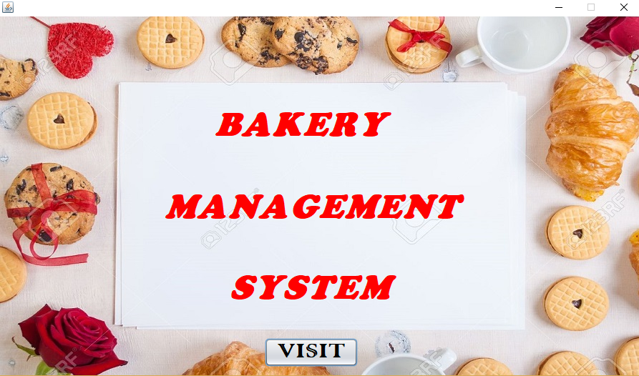

**OPTION LOGIN FORM**

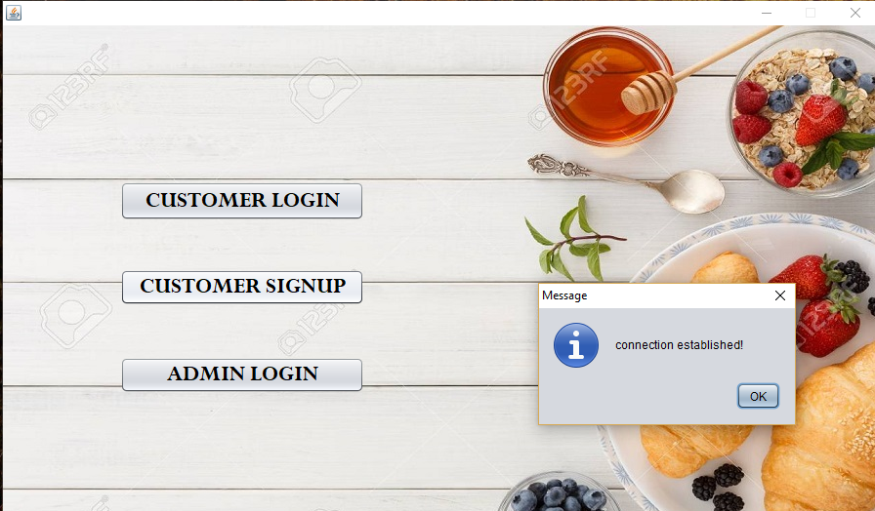

**SIGN UP FORM**

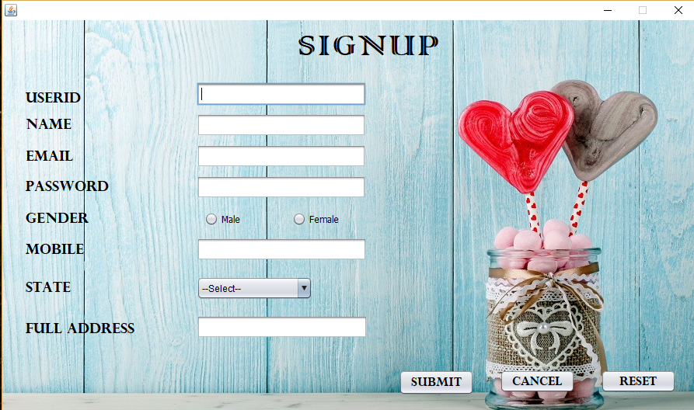

**LOGIN FORM**

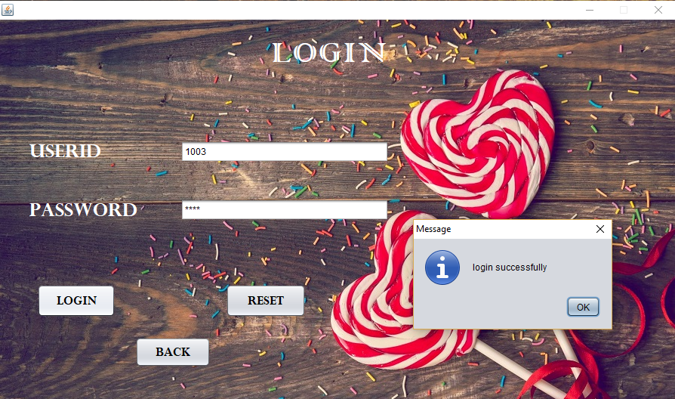

**CONTACT US FORM**

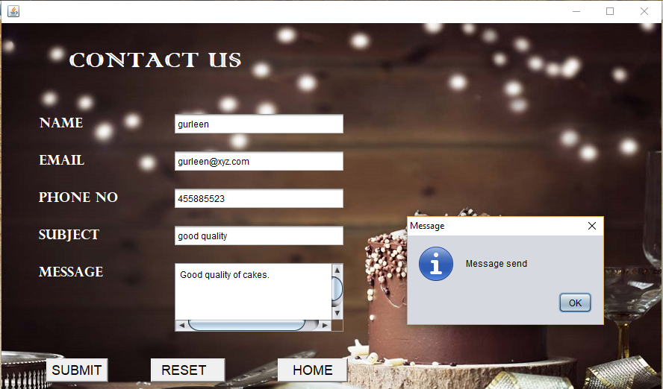

**PASTRIES FORM**

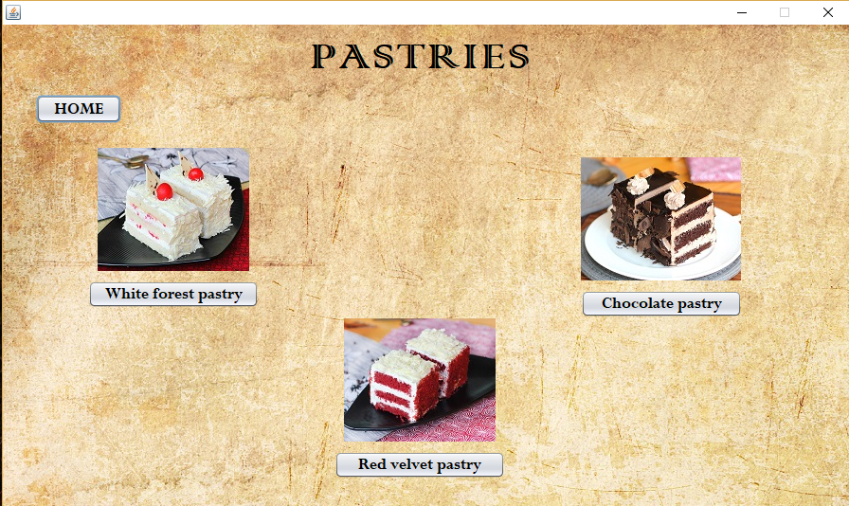

**COOKIES FORM**

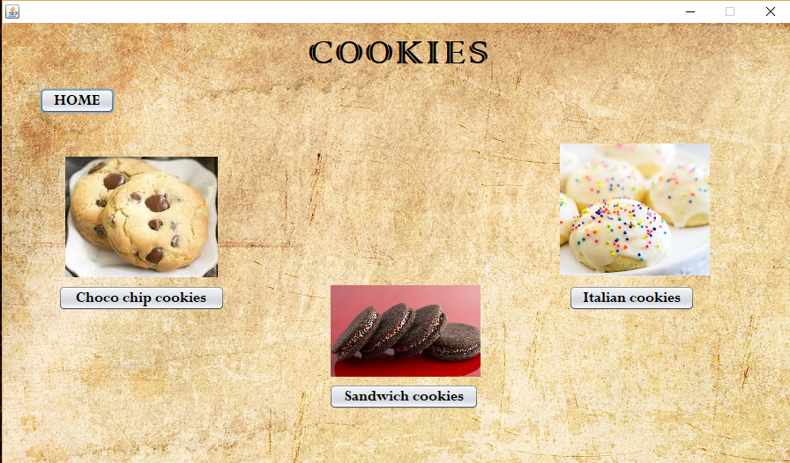

**BREAD FORM**

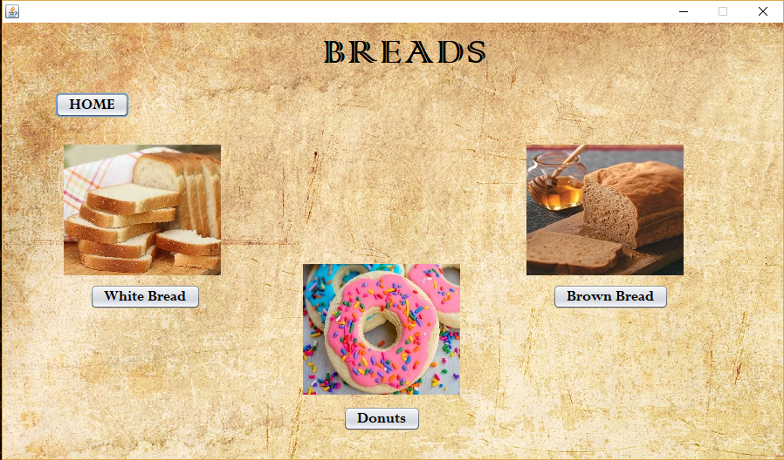

**CAKES FORM**

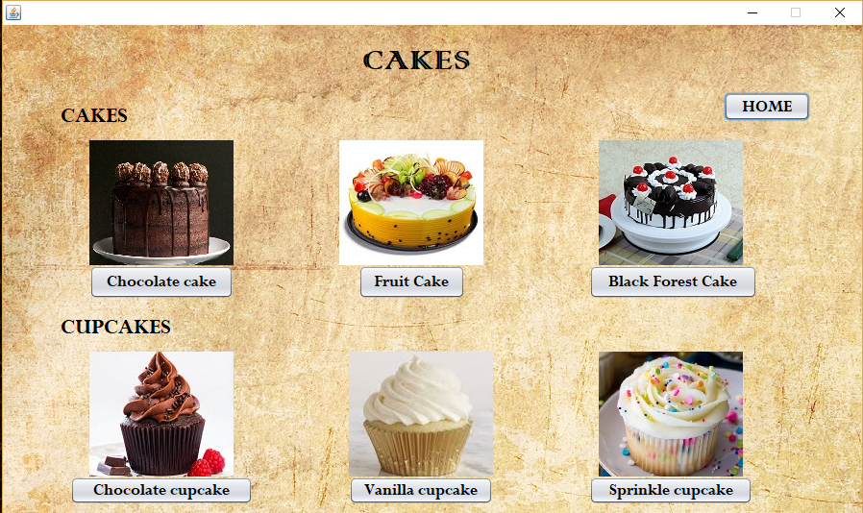

**CHOCOLATE CAKES FORM**

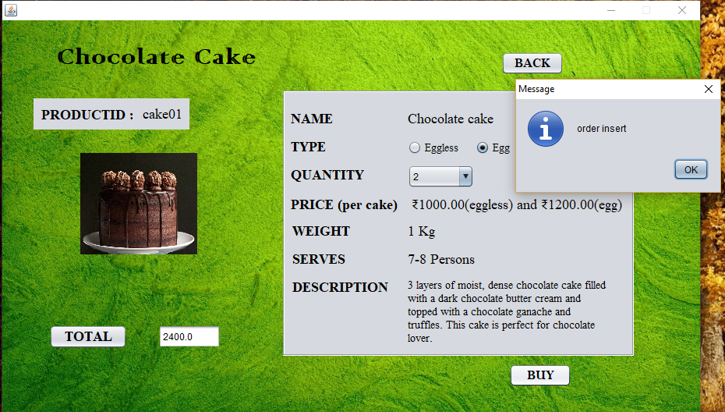

**SHIPPING ADDRESS FORM**

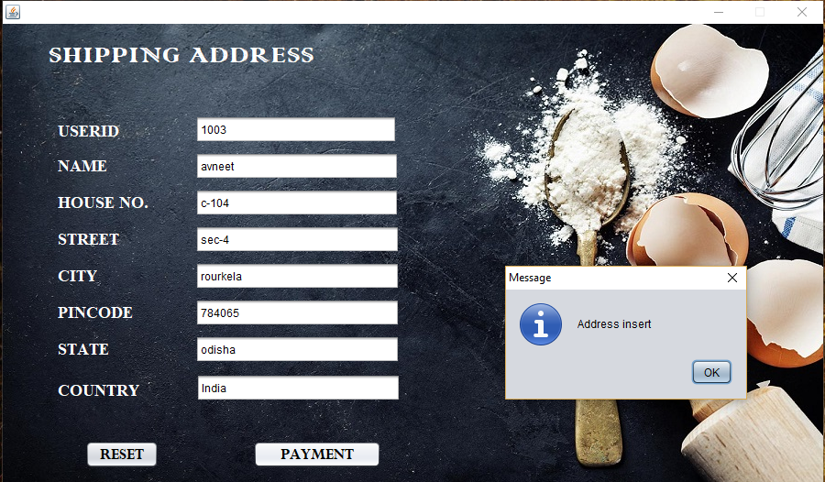

**PAYEMENT FORM**

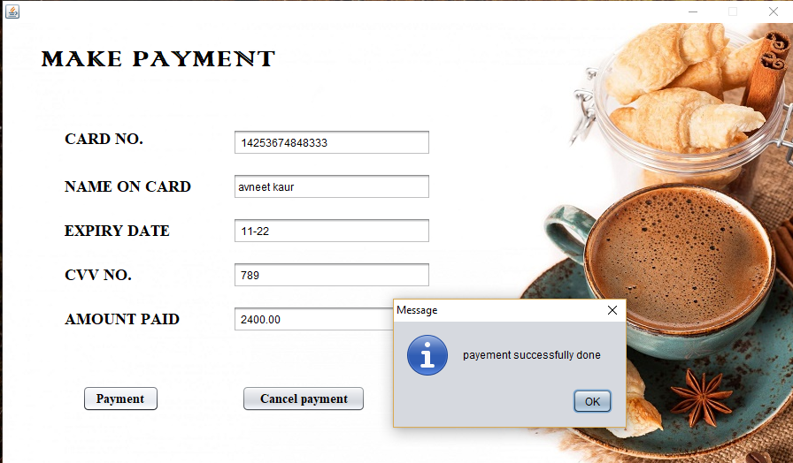

**ADMIN LOGIN FORM**

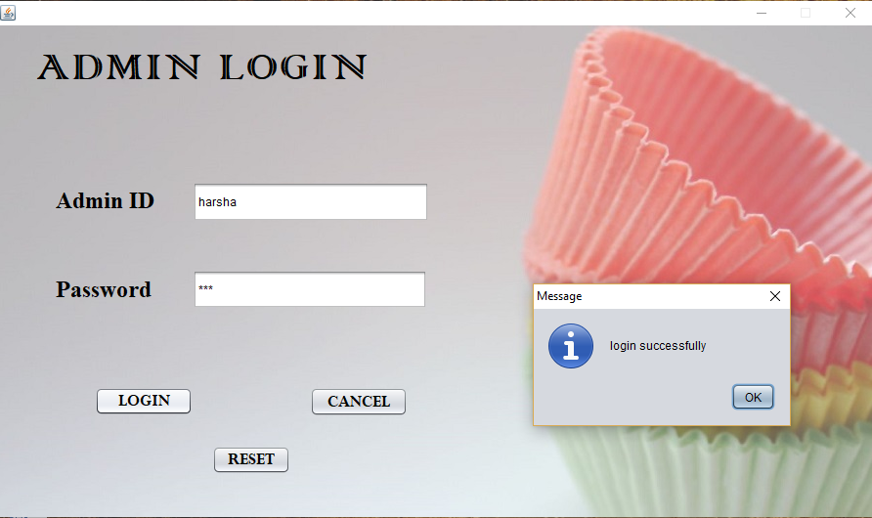

**ORDER FORM** 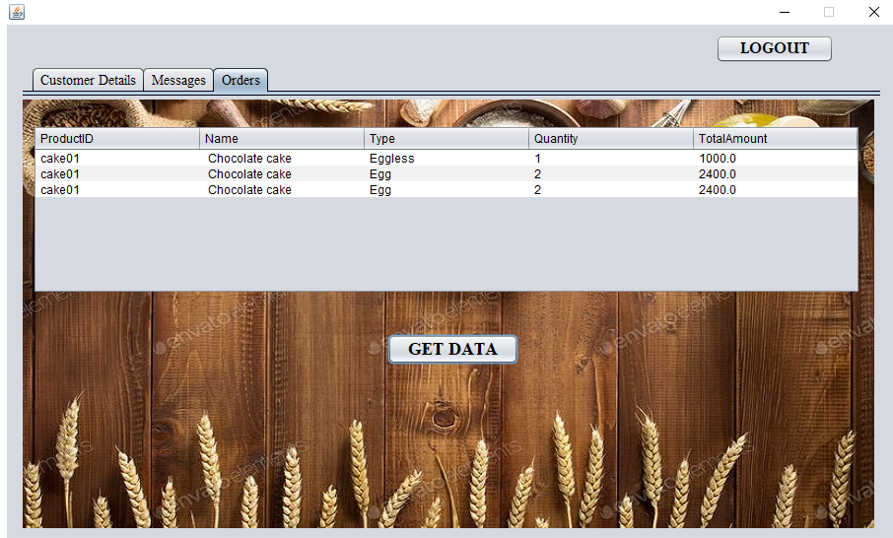

**CUSTOMER DETAILS FORM**

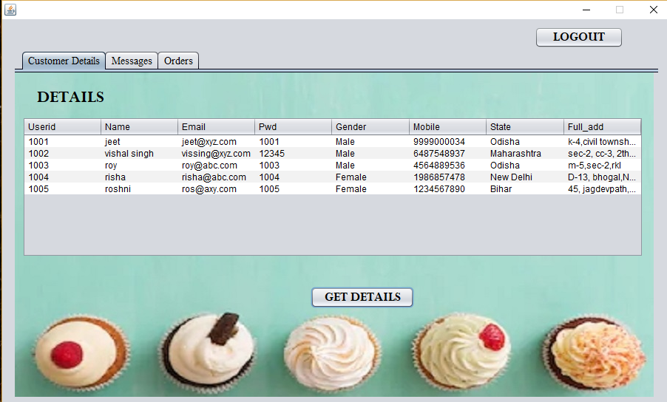

**MESSAGE FORM**

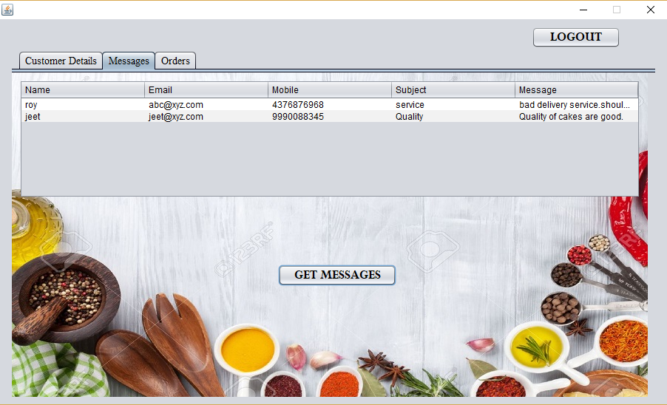

**DATABASE TABLE**

**SIGNUP AND LOGIN TABLE (Info table)**

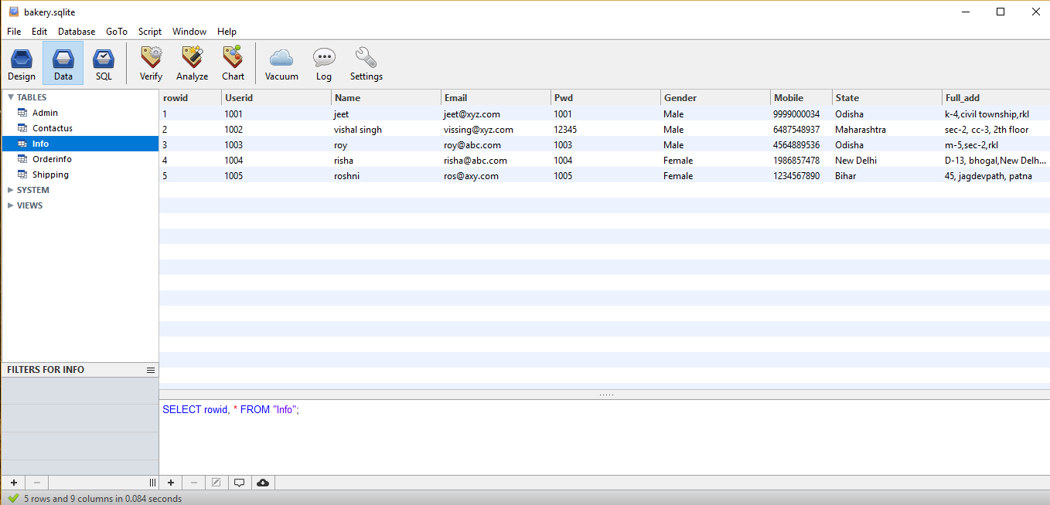

**ADMIN LOGIN TABLE (Admin table)**

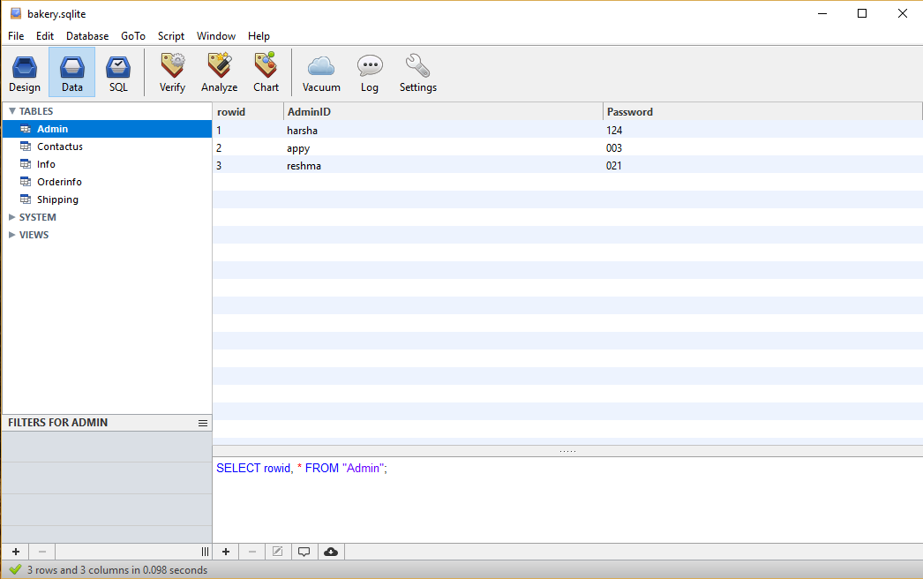

**CONTACT US**

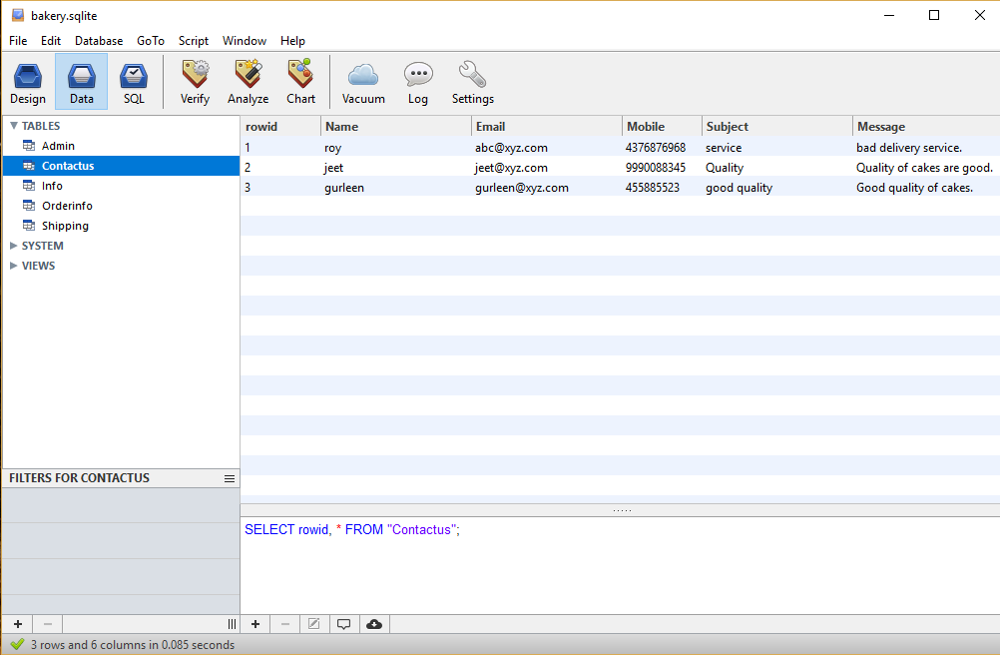

**ORDER DETAILS**

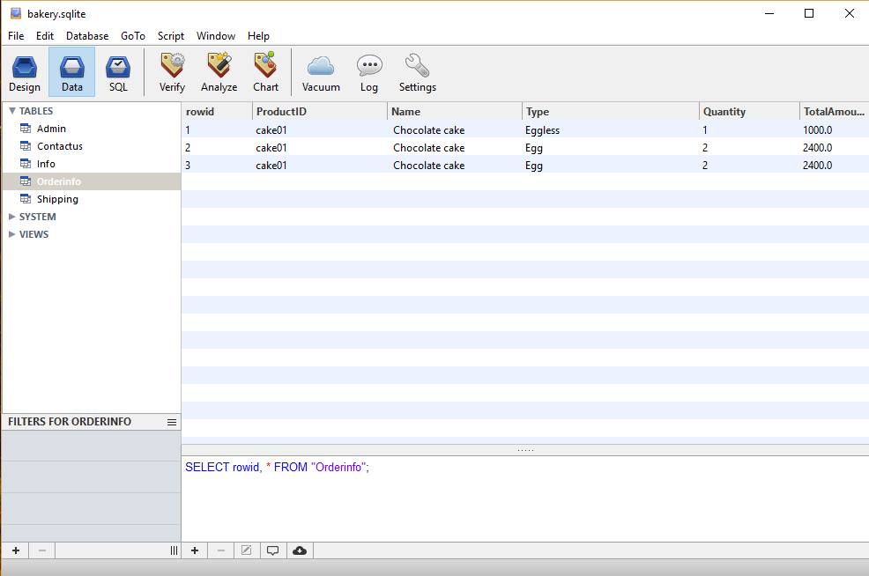

**SHIPPING ADDRESS**

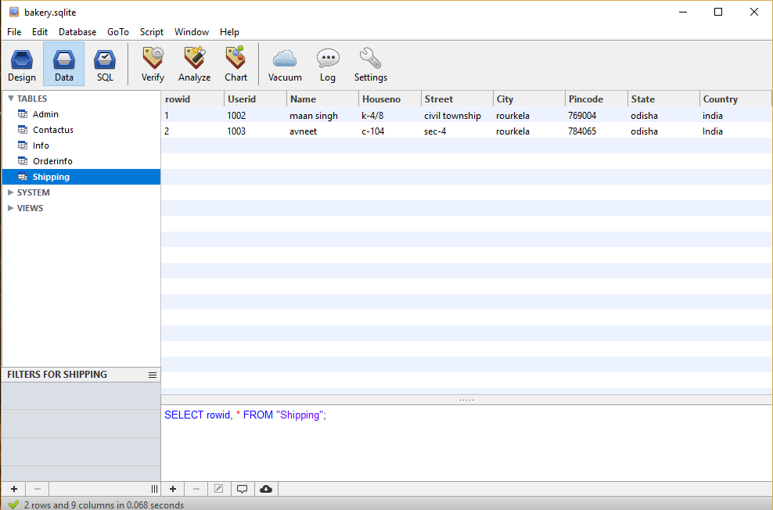

**CONCLUSION**

In most of the previous system based on bakery management we found many flaws and lack of essential facilities which really could hamper the most of the user needs which is not acceptable for the people who desire for a system which could serve their purposes, after a long studies and effort we have come up with a system in the form of an application named “BAKERY MANAGEMENT SYSTEM”

An application which we introduced is different from the rest of the previous existing one. What makes it unique is the way of its user comfort design and facilities such as authenticated logging, maximum details of the users in order to eradicate chaos, convenient issues and return feature of less key stroke that is with the help of single id most of the information could be retrieved and many more.

Hope that this research and as a result the application produced will be fruitful to you and all its user. However, our systemits dynamic system which means if you find any flaws or bug, changes can be made as and when required and even the new features can be also appended with the going trends.

**FUTURE SCOPE**

The application is now a stand-alone application which can be connected with PHP or .net for further online processing.

This system application is convenient to computerized all the sales activities related to bakery. It focuses on the seller and the customer to provide online sales and related activities.

The application provides shipping facilities where people can sign up to create their user id provided with a particular password where they can add their personal details which help them to order the bakery products and further process with shipping.

People can make payment through online transaction using their Debit Card or Credit Cards or Cash on delivery.

**REFERENCES**

<https://www.javatpoint.com/>

<https://www.youtube.com/watch?v=OAWNXo1xv6w&t=228s>

<https://www.youtube.com/watch?v=hIZyJzP96Pg>

<https://www.youtube.com/watch?v=0EZQLyfCVWQ>